# **Why RNNs are needed | RNNs Vs ANNs | RNN Part 1**

# 

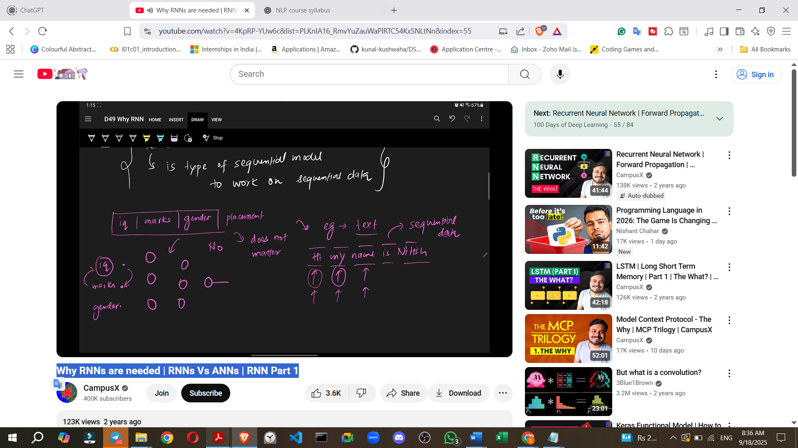

# 

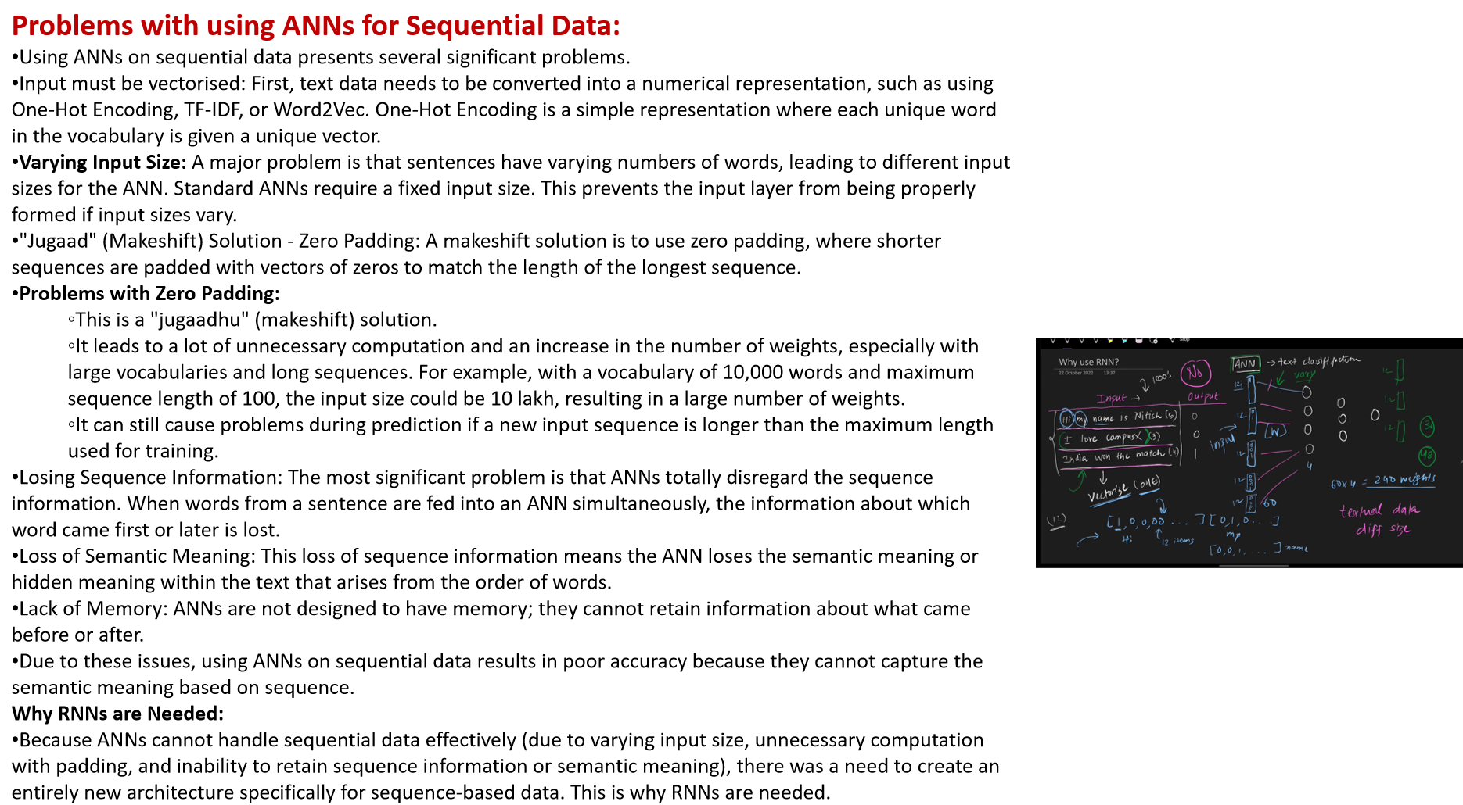

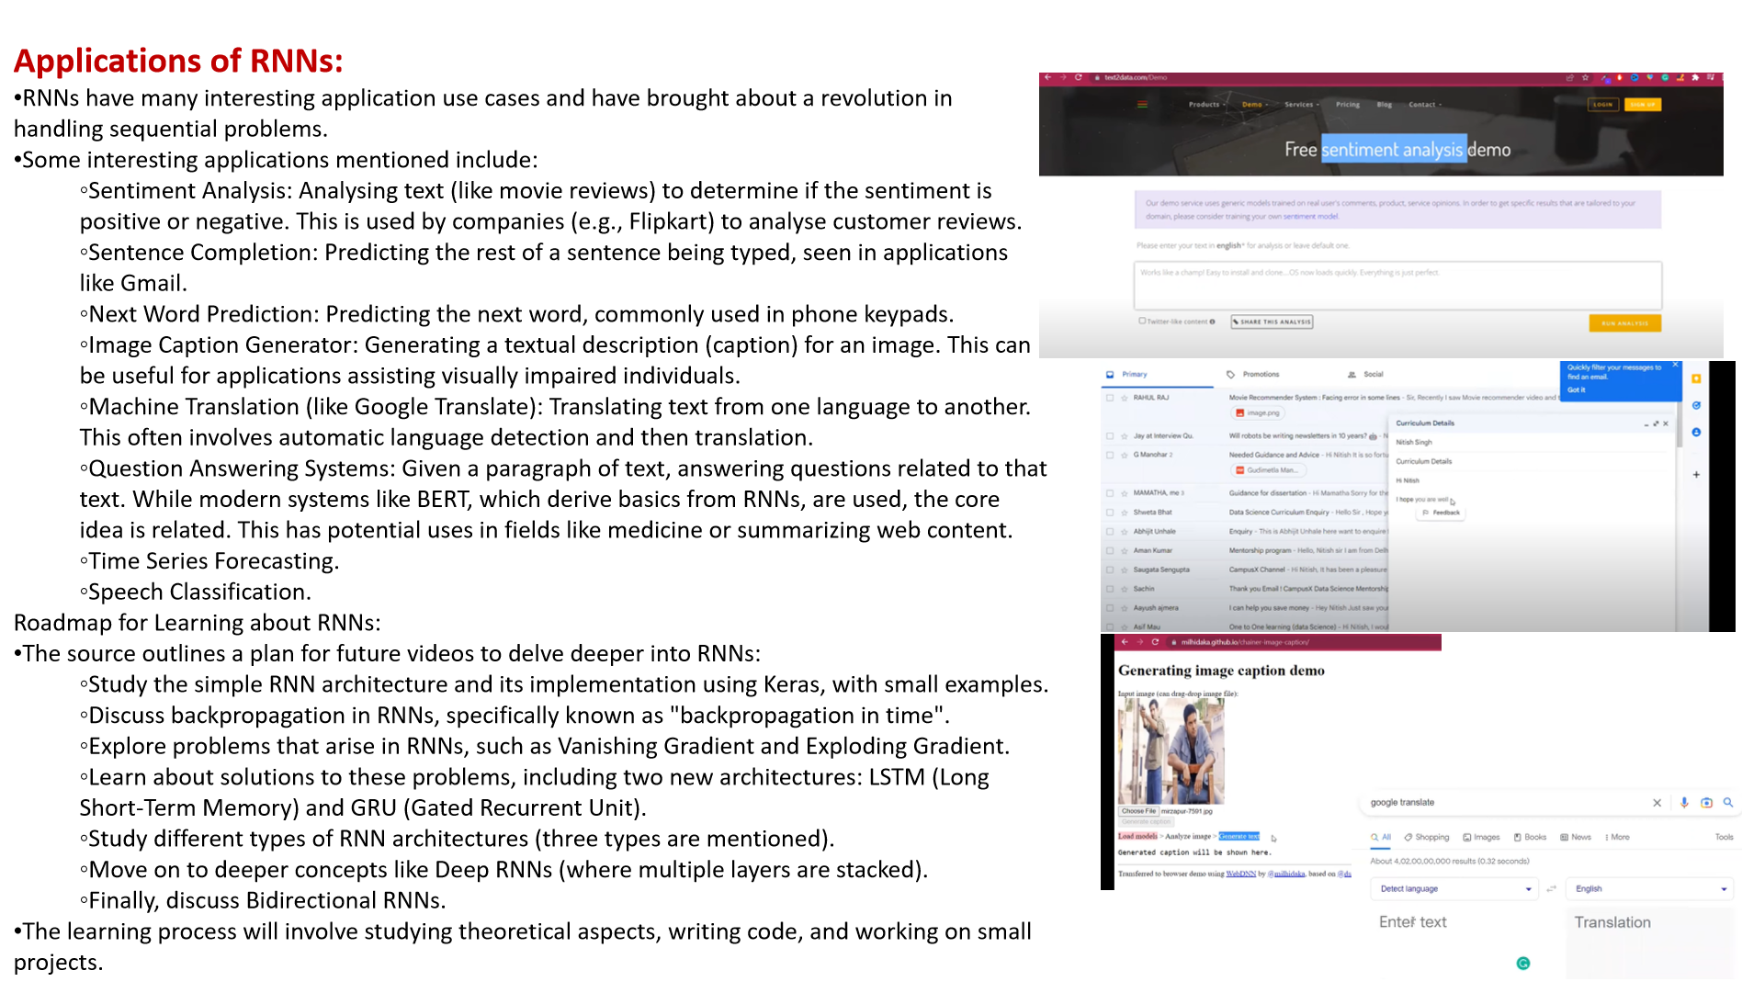

<https://milhidaka.github.io/chainer-image-caption/>

# **Class 2. Recurrent Neural Network | Forward Propagation | Architecture**

Here is a note summarising the architecture of Recurrent Neural Networks (RNNs) and the process of forward propagation, based on the provided sources:

**Recurrent Neural Networks (RNNs)**

**Why RNNs are Needed**

* RNNs are required for handling **sequential data**.
* Standard neural networks like ANNs and CNNs do not work well with sequential data.
* This is primarily because sequential data can be of **any length**, which is problematic for ANNs that generally work with fixed input sizes. For example, movie reviews have varying numbers of words, making it difficult to use a fixed-size input layer for an ANN.
* Feeding sequential data into an ANN all at once would lead to a very large input layer and high computational cost.
* More importantly, sequential data contains inherent **meaning in the sequence**; the later elements depend on the earlier ones. ANNs process inputs independently, thus losing this crucial sequential information.
* RNNs are a special class of neural networks designed with a **memory feature**, allowing them to remember past inputs and work effectively with sequential data.

**RNN Architecture**

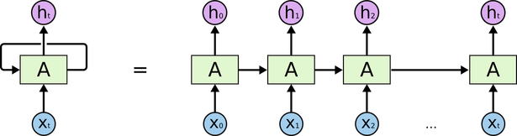

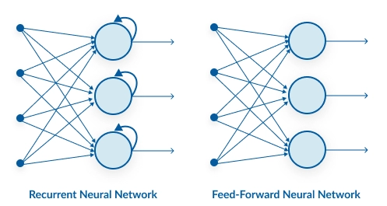

* An RNN architecture is similar to an ANN in having input, hidden, and output layers.
* However, unlike ANNs, RNNs process the input **one element at a time**, based on time steps.
* The key difference is that RNNs are **not feedforward** networks.
* RNNs incorporate a **concept of state**.
* The **hidden layer sends a feedback** connection back to itself. This connection is what makes an RNN "recurrent" and is the biggest difference from a feedforward network.
* The output (or activation) of the hidden layer from the current time step is fed back as an input to the same hidden layer for the **next time step**.
* The input layer size is determined by the number of features representing each element in the sequence (e.g., 5 nodes for 5-number word vectors in the sentiment analysis example).
* The output layer size depends on the problem (e.g., 1 node with a Sigmoid activation for binary classification like sentiment analysis).
* The number of nodes in the hidden layer can be chosen (e.g., 3 nodes in the example).

**Data Input Format**

* Data is typically input into an RNN in the form: **Time steps x Input features**.
* For simple RNN classes, the shape might be **Batch size x Time steps x Input features**, allowing multiple sequences to be processed together.
* Each word in a review, for instance, is represented as a vector (e.g., a 5-number vector for a 5-word vocabulary).

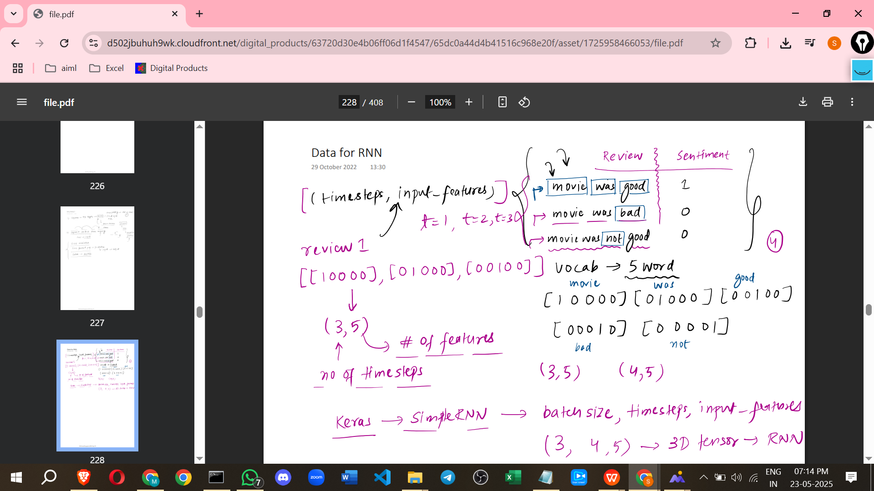

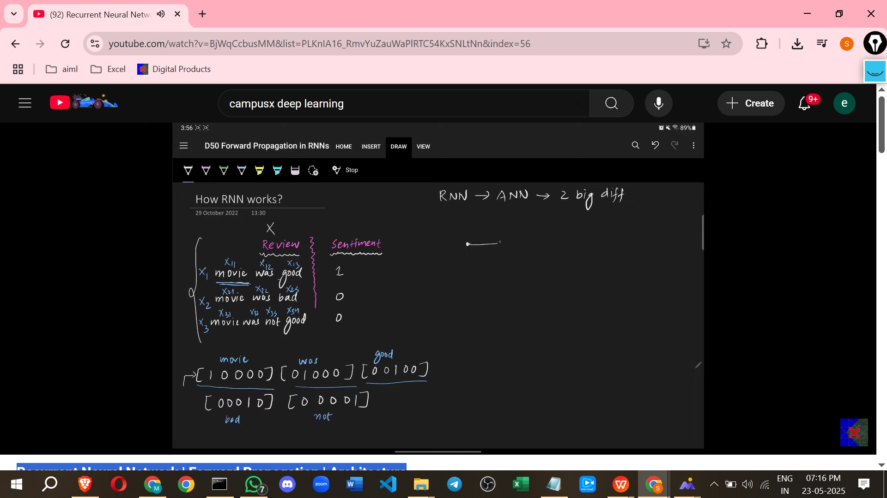

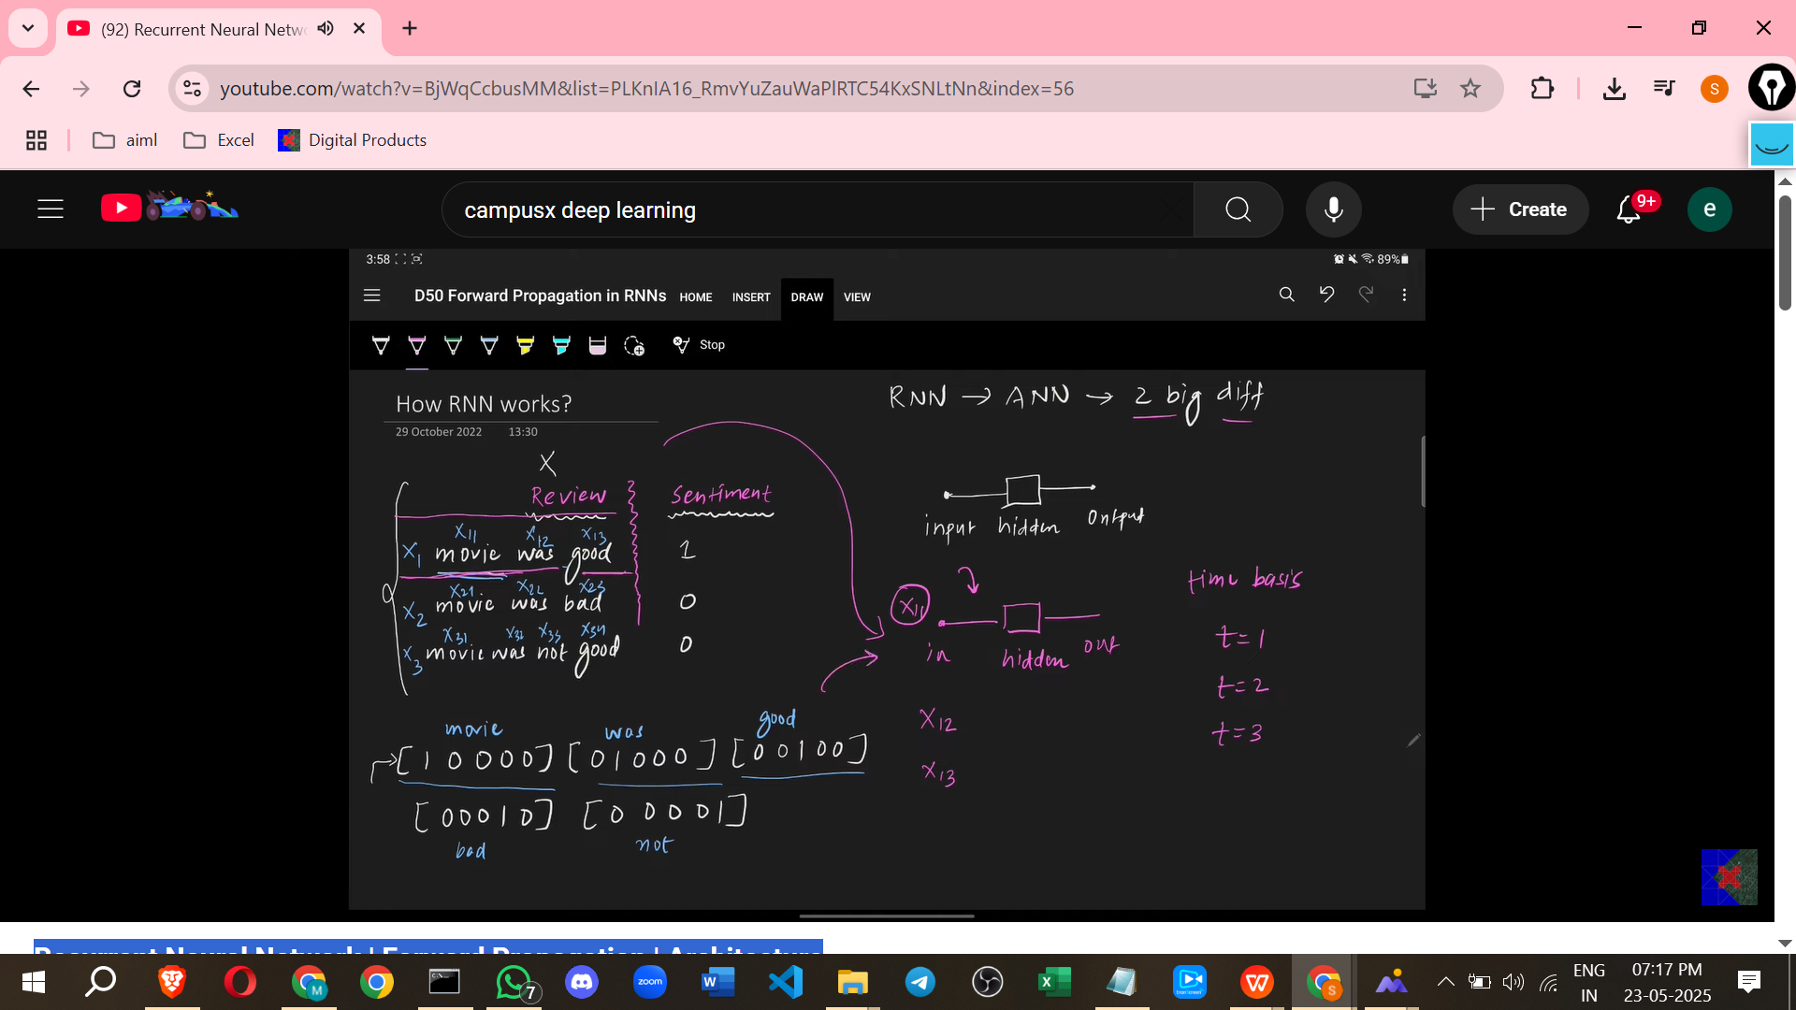

RNN NOT ONLY FFN IT ALSO SEND BACK DATA

**Forward Propagation in RNNs (Prediction)**

* Forward propagation in an RNN involves a process called **unfolding through time**.
* The recurrent layer acts like a **loop**.
* The core idea is that the network (specifically the hidden layer and its connections) is **reused** for each time step, but with different inputs.
* Crucially, the **same weight values** are used across different time steps; this is known as **parameter sharing** or weight sharing.

Let's trace the forward pass through time (using an example like the sentiment analysis with 5 input features and 3 hidden nodes):

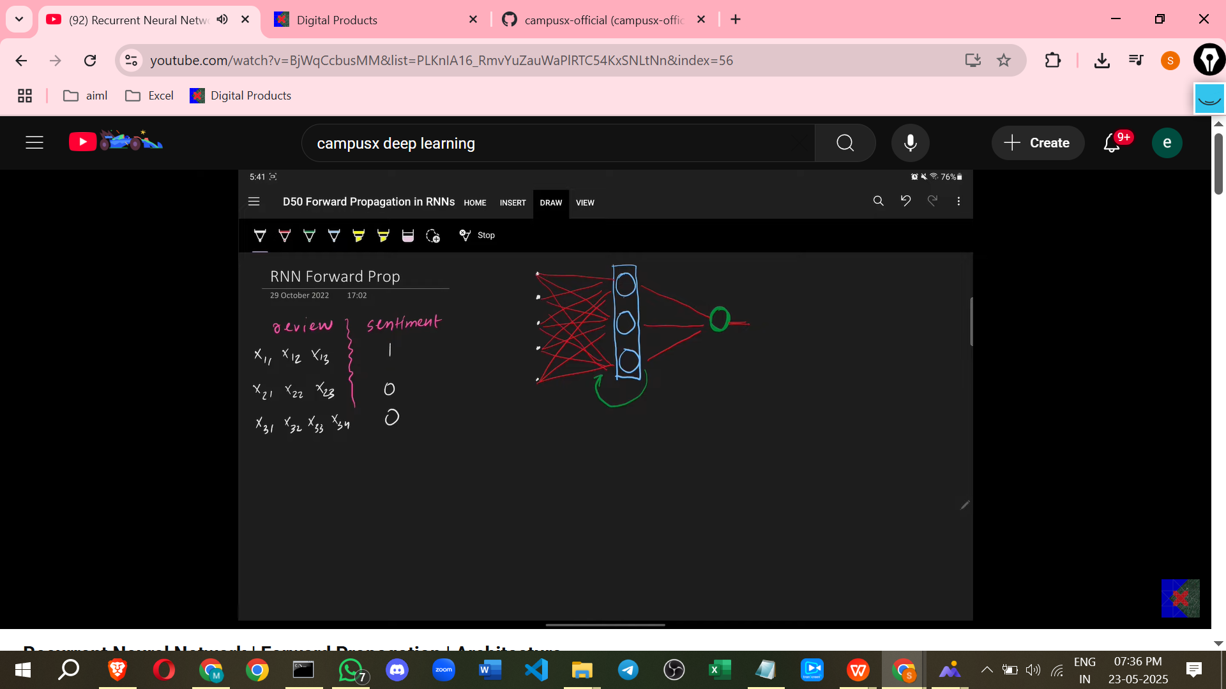

* **Time step T=1 (Processing the first word, X11)**
  + The first word vector (X11, shape 1x5) is input.
  + Inside the RNN, this input is processed. It is dot producted with the **input-to-hidden weight matrix (Wi)**.
  + An input representing the "previous" hidden state is also used. For the first time step (T=1), since there is no previous state, this input is typically **initialised (e.g., with zeros)**. This previous hidden state (H0) is dot producted with the **hidden-to-hidden weight matrix (Wh)**.
  + The results of these two dot products (Wi * X1 + Wh * H0) are added. Biases are also added (though not explicitly detailed in the calculation step, they are present in the architecture).
  + This sum is passed through an **activation function** (like Tanh, ReLU, etc.) to calculate the hidden state at time T=1 (H1). Tanh is often the default activation for the hidden layer.
  + H1 (shape 1x3) is produced. H1 is then fed back to the hidden layer for the next time step.
  + To get the output at T=1 (O1 or Y1), H1 is dot producted with the **hidden-to-output weight matrix (Wo)**, a bias is added, and the result is passed through the **output activation function** (Sigmoid for binary classification).

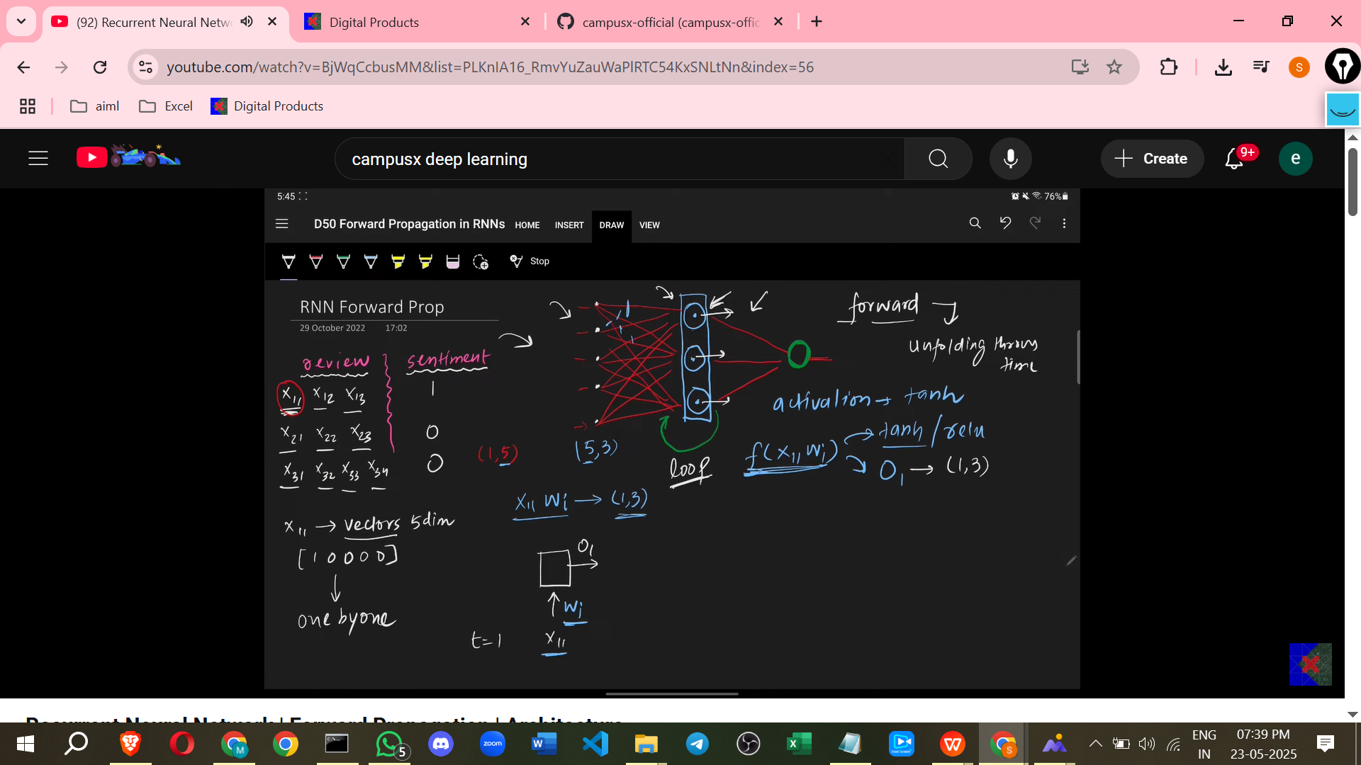

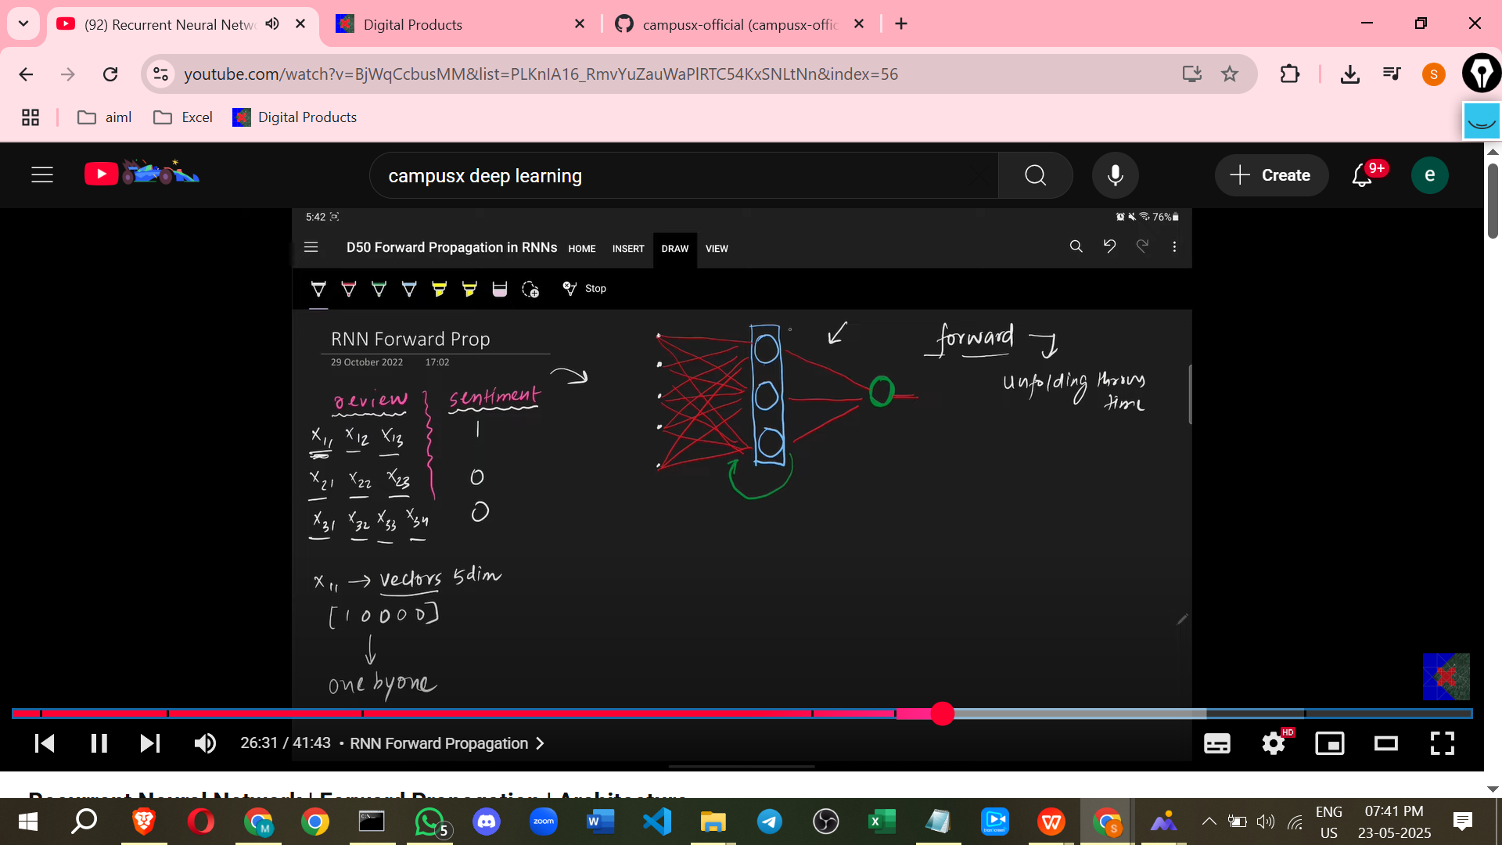

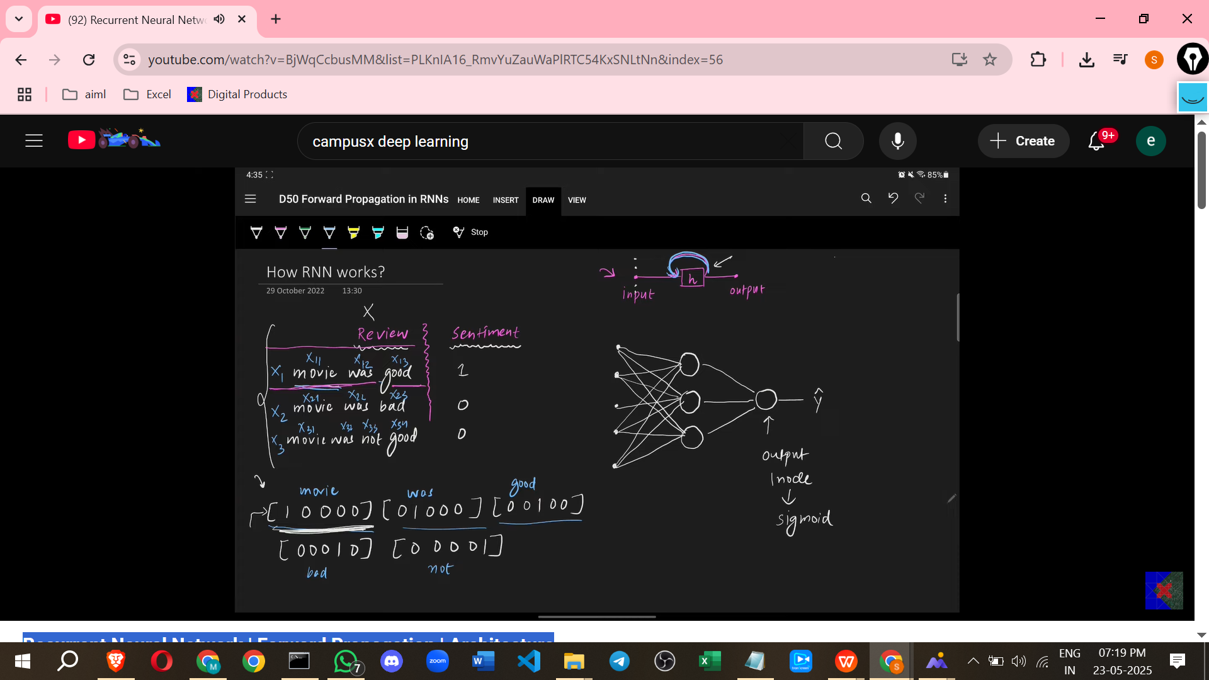

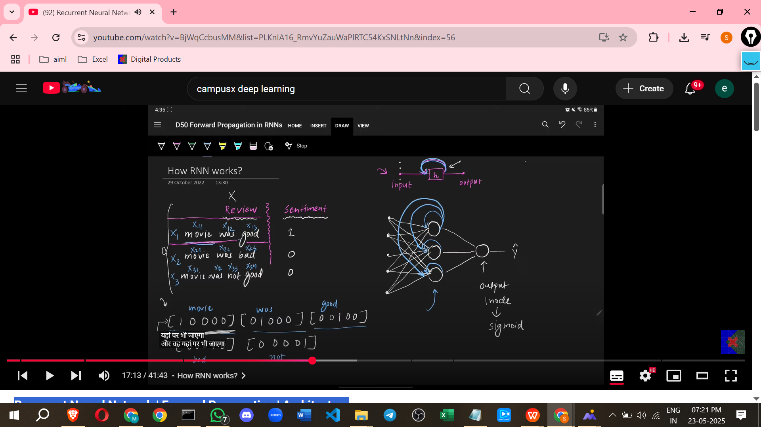

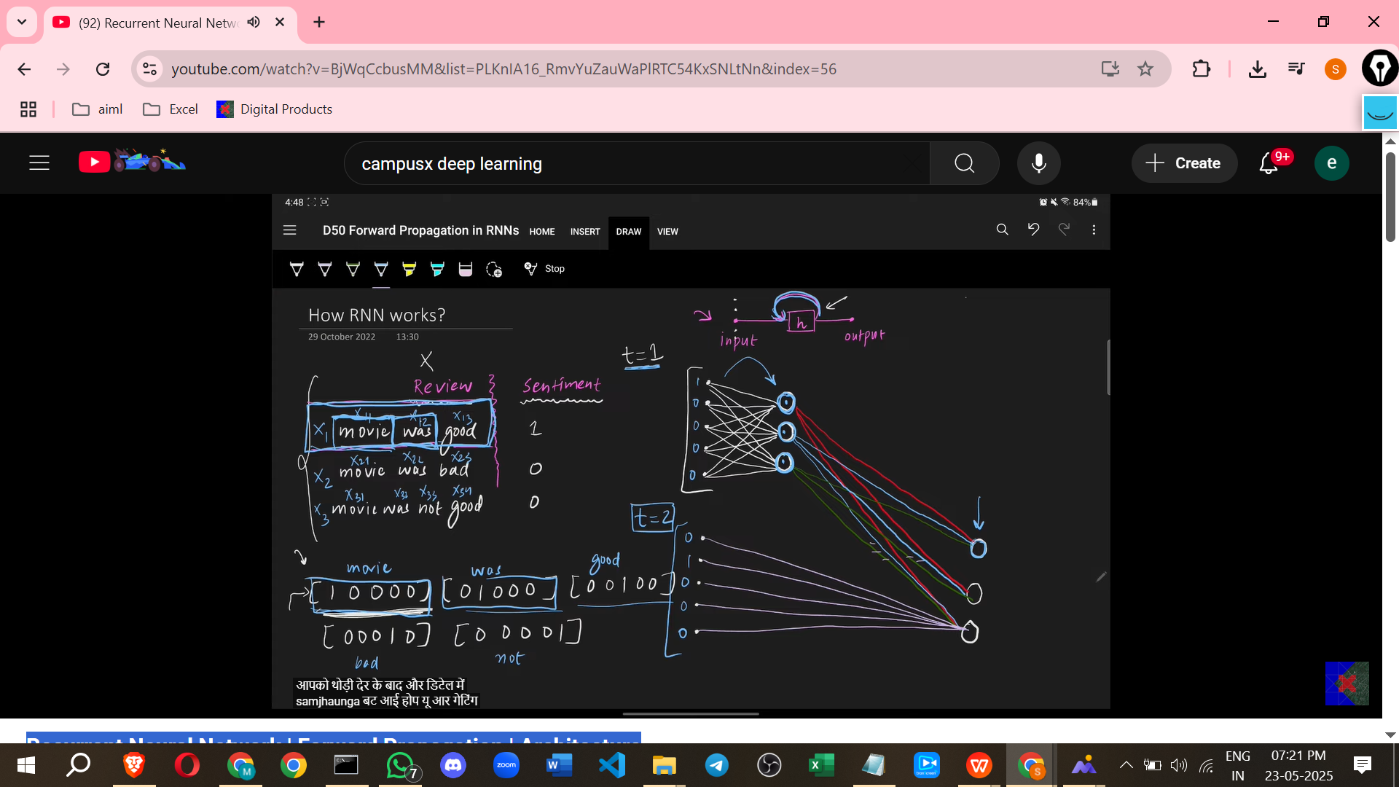

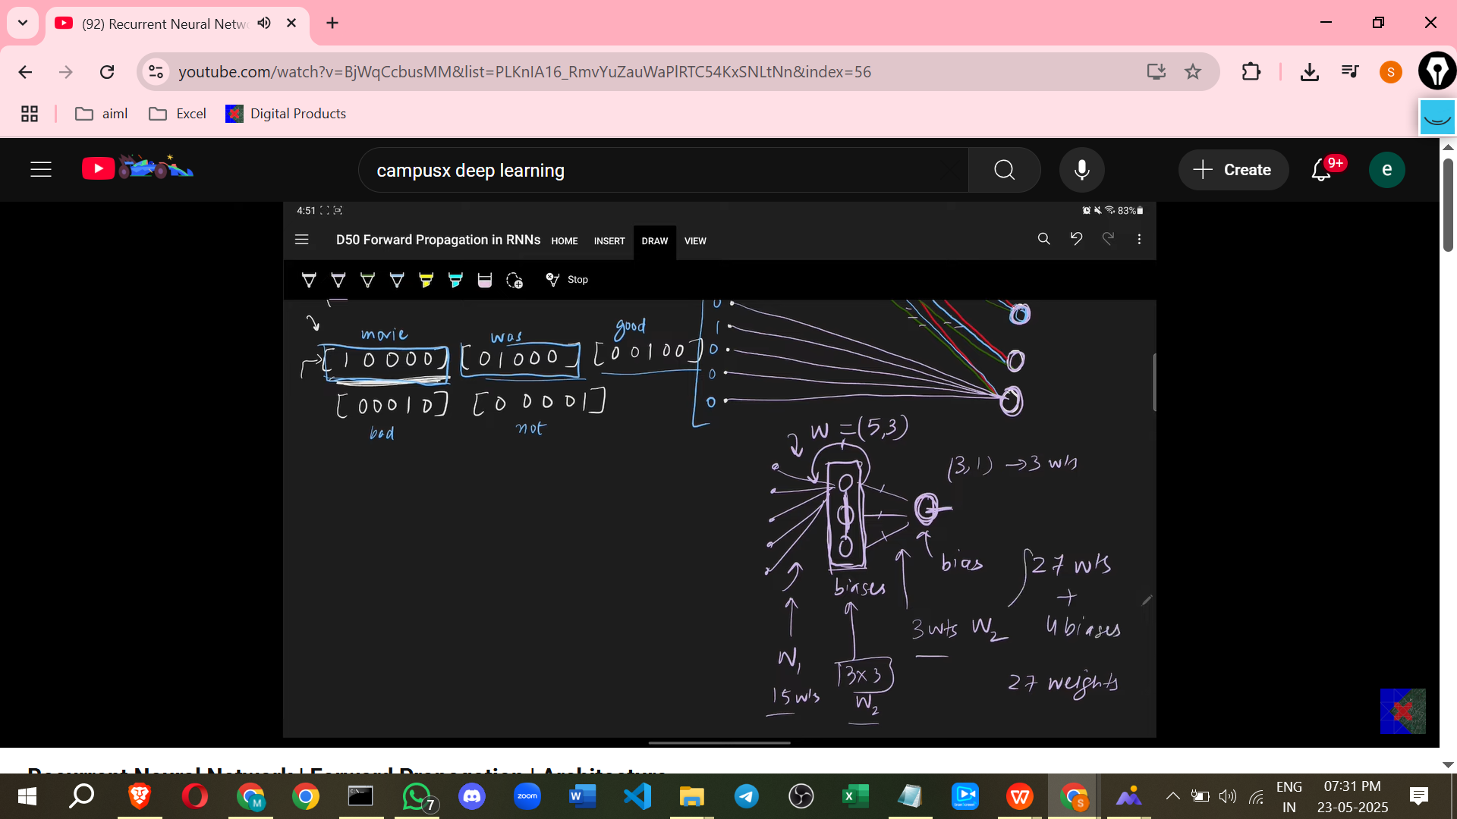

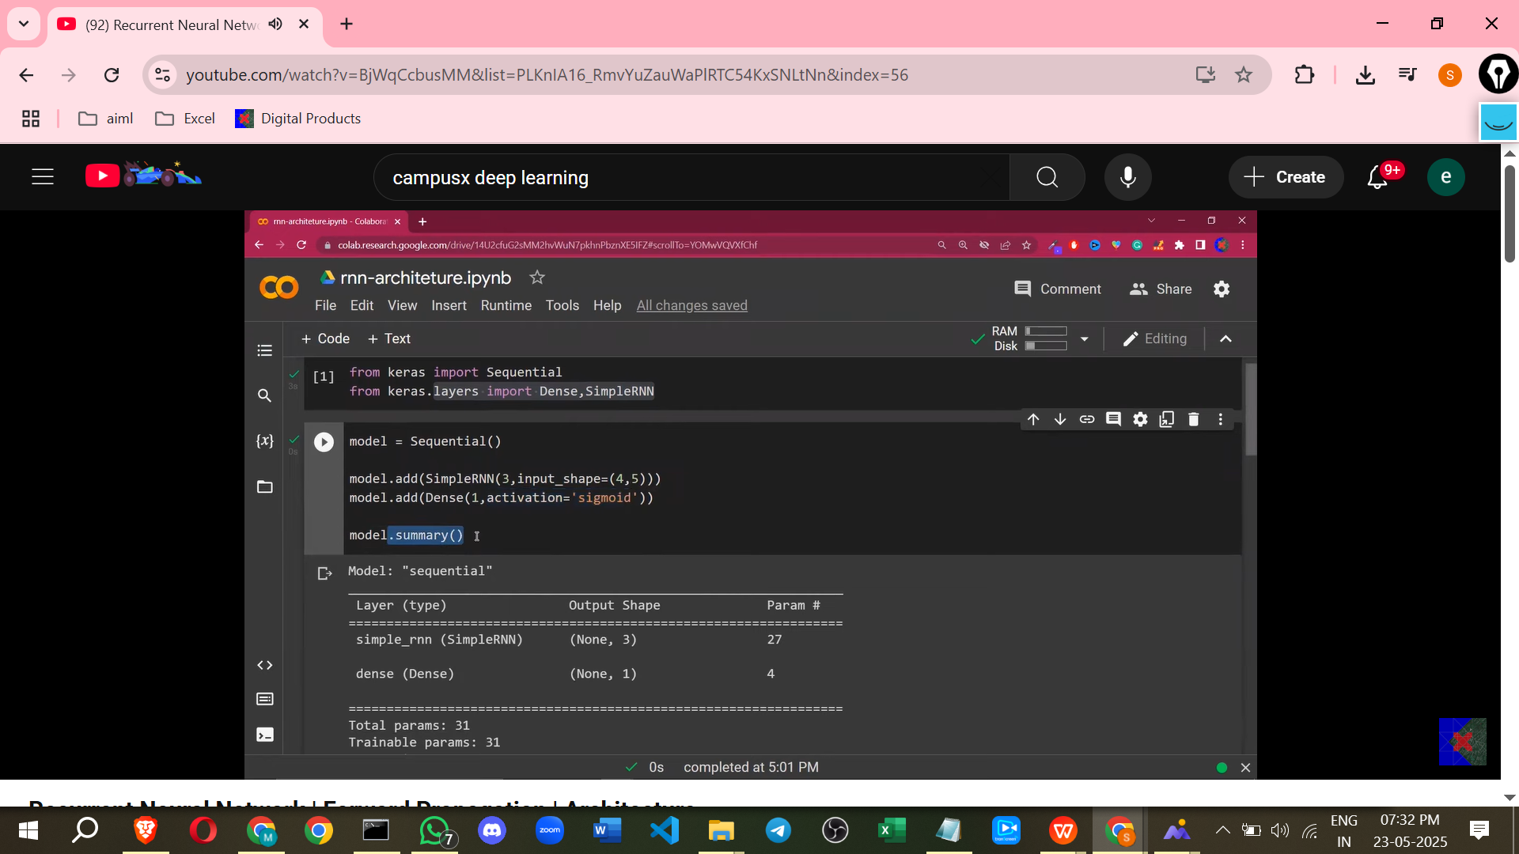

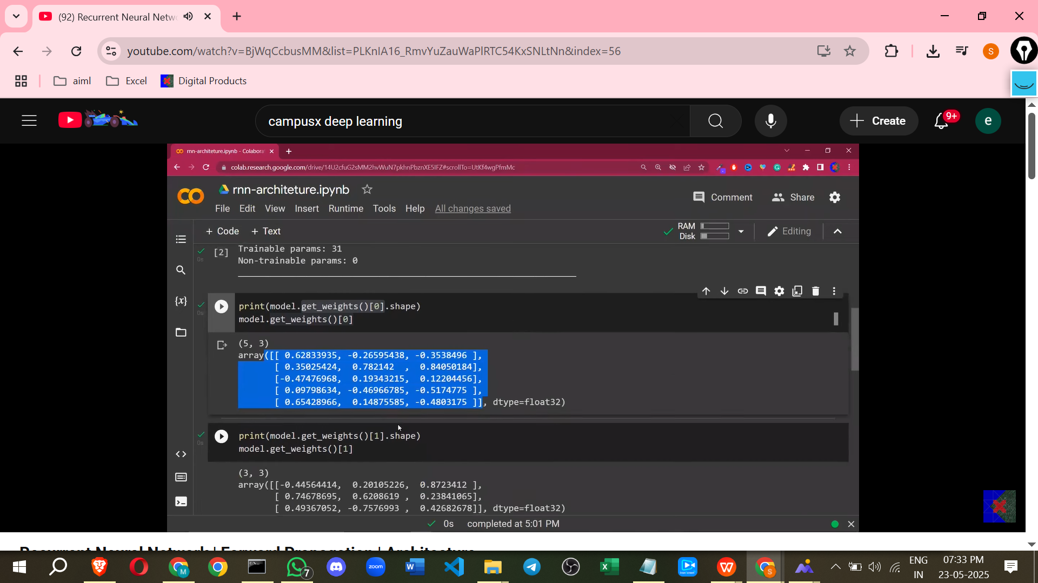

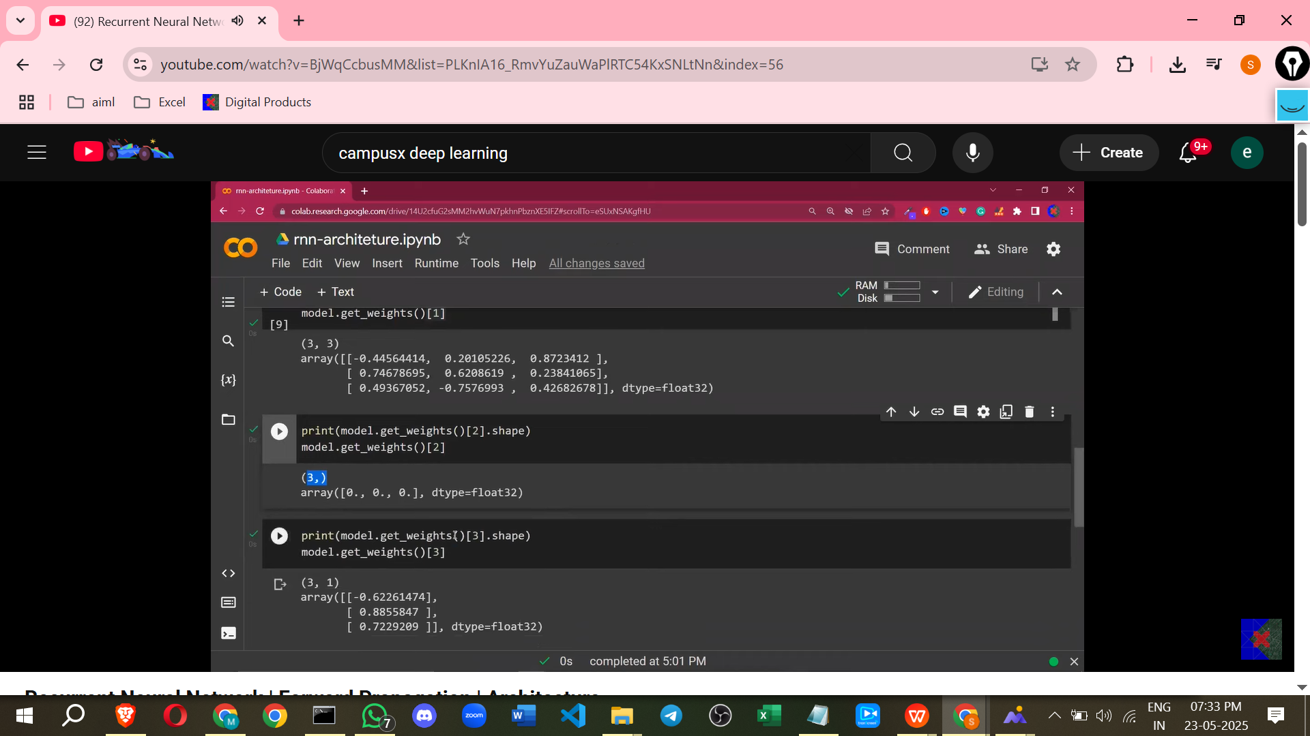

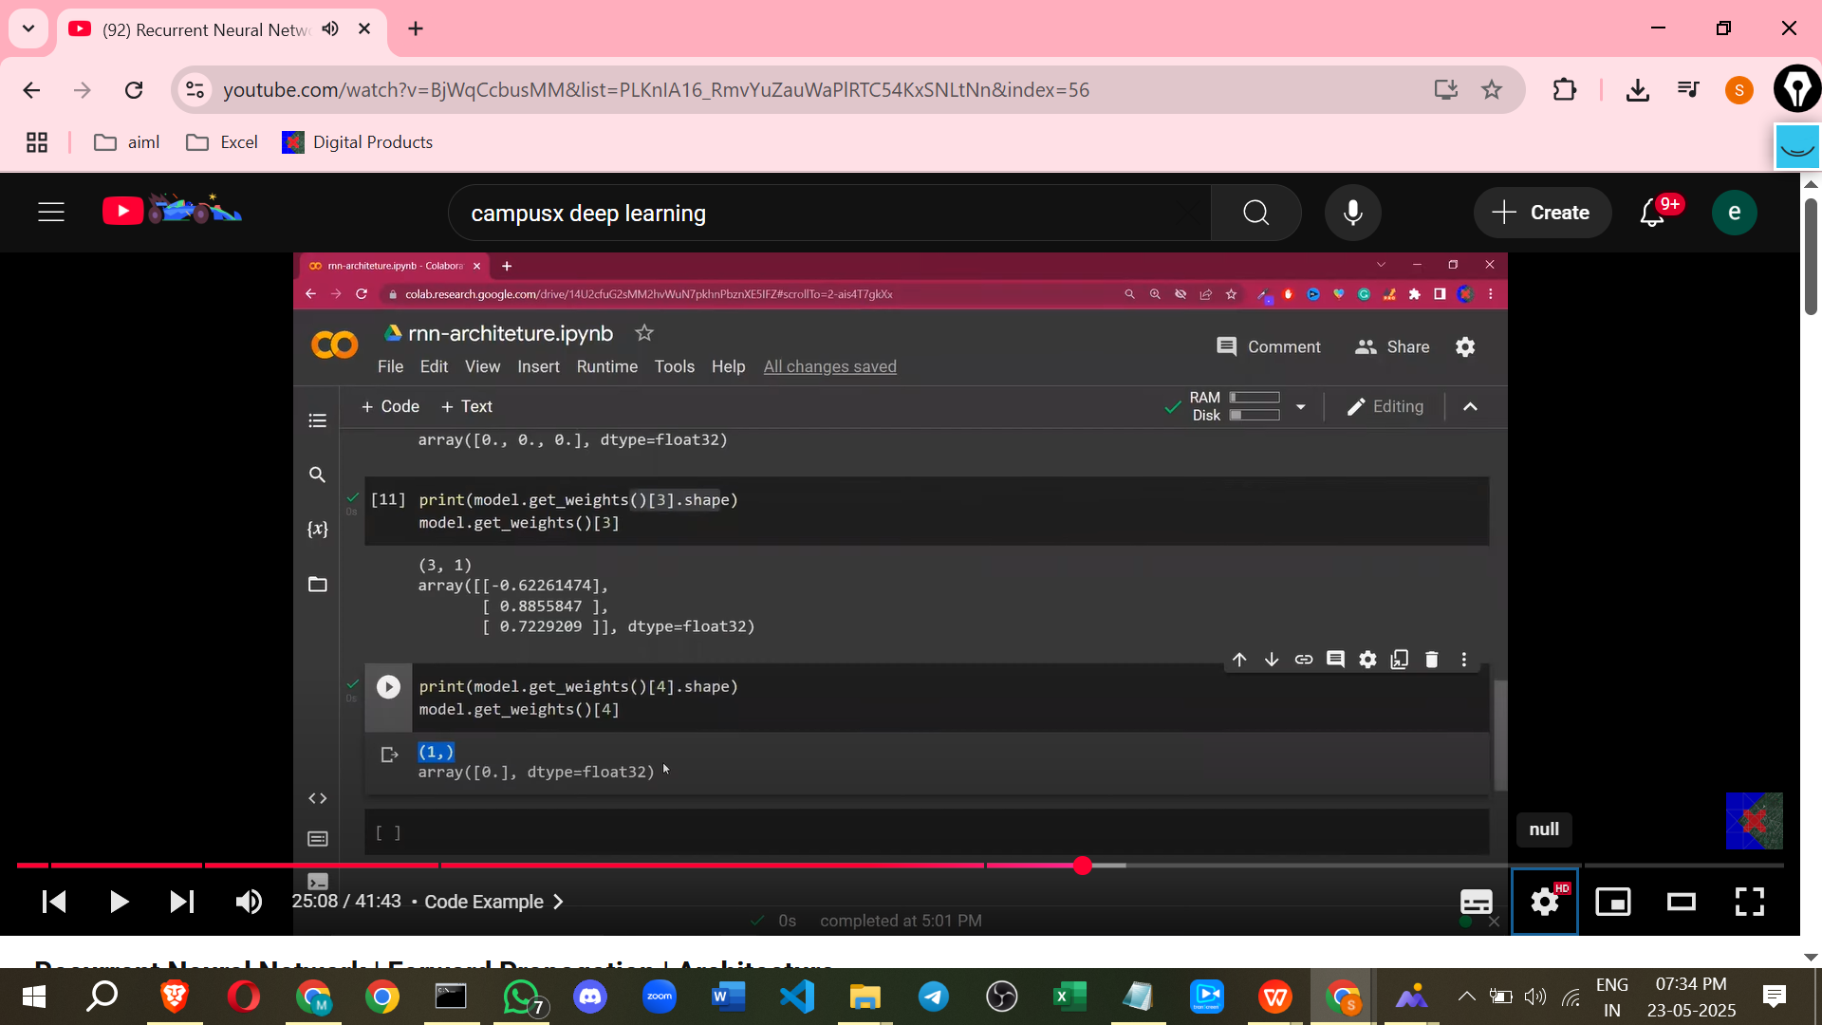

* **Time step T=2 (Processing the second word, X12)**
  + The second word vector (X12, shape 1x5) is input and dot producted with Wi.
  + The **hidden state from the previous time step (H1)** is also input and dot producted with Wh.
  + These results (Wi * X2 + Wh * H1) are added (plus biases) and passed through the hidden layer activation function to calculate the hidden state at time T=2 (H2).
  + H2 is produced and fed back for the next time step.
  + O2 (or Y2) is calculated by dot producting H2 with Wo, adding bias, and passing through the output activation function.

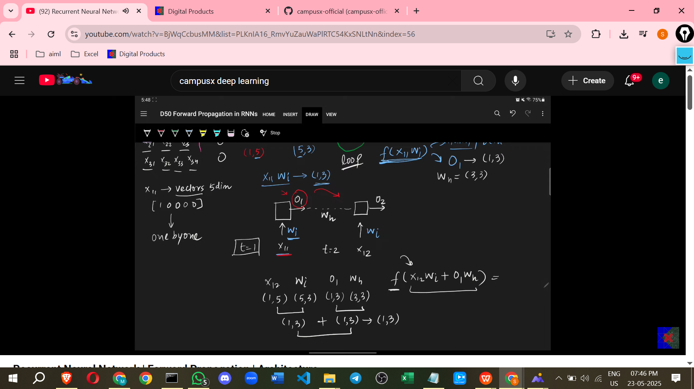

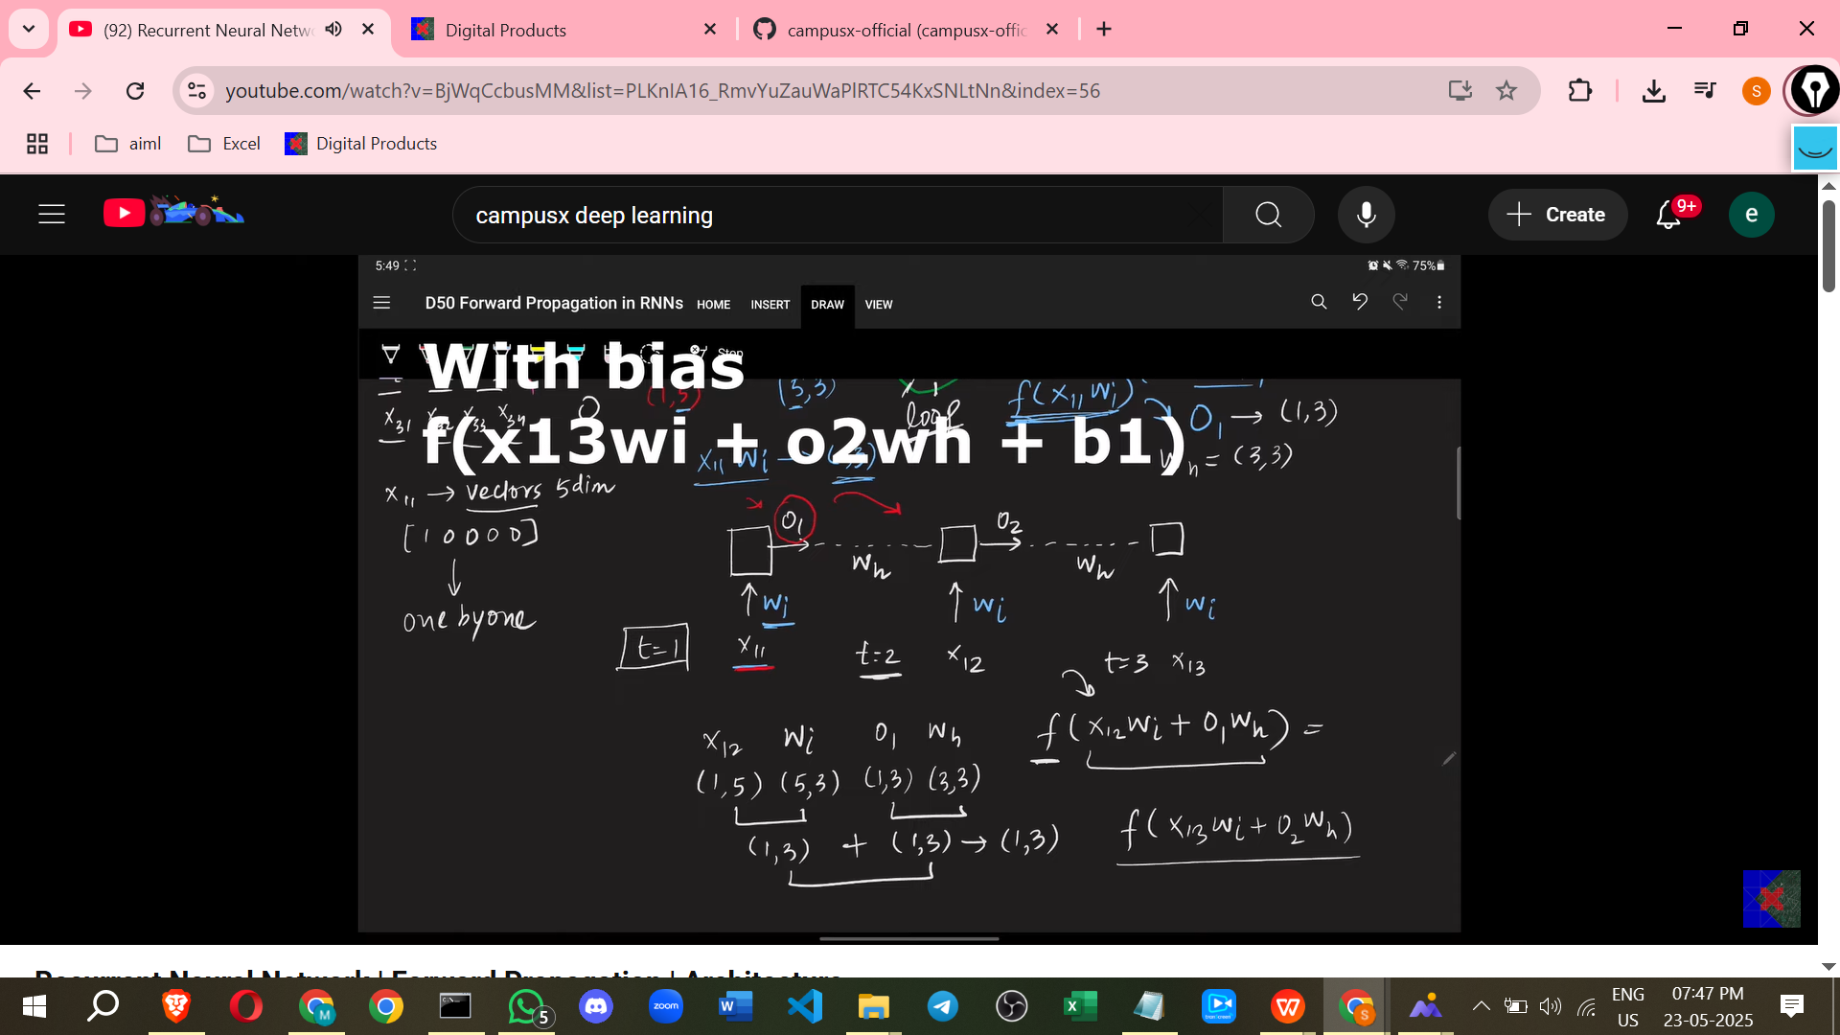

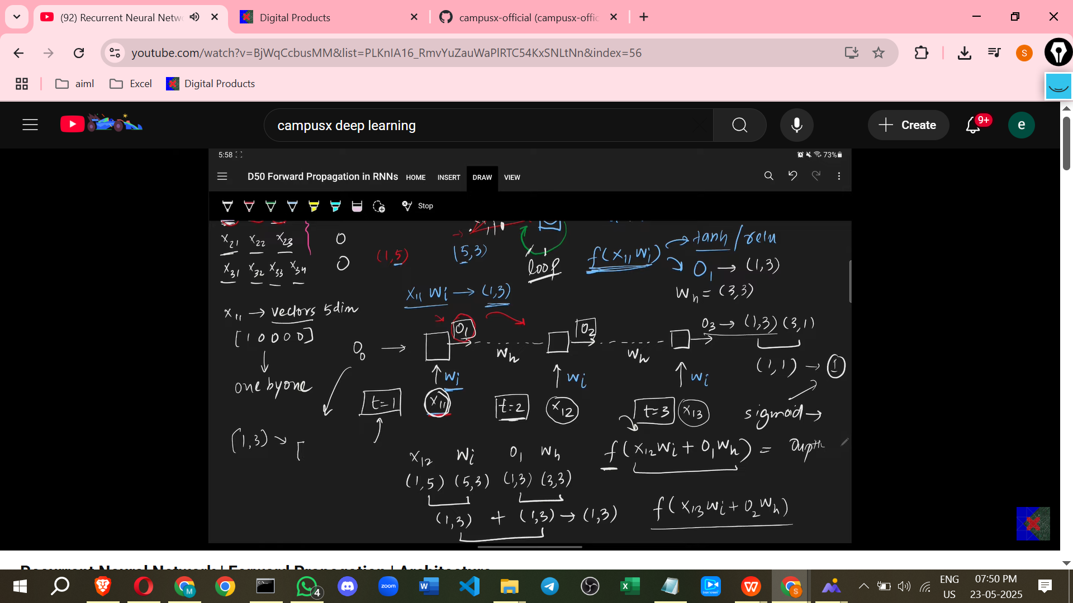

* **Subsequent Time steps**
  + This process repeats for all words/time steps in the sequence.
  + At each time step 't', the current input word vector (Xt) and the hidden state from the previous time step (Ht-1) are used to calculate the current hidden state (Ht) and the current output (Yt).
  + The calculation for the hidden state at time 't' (Ht) is typically: Activation(Wi * Xt + Wh * Ht-1 + bias).
  + The calculation for the output at time 't' (Yt) is typically: Output_Activation(Wo * Ht + output_bias).
* **Final Output**
  + For sequence classification tasks (like sentiment analysis of a whole review), the **final output** (at the last time step) is often used as the prediction for the entire sequence. However, outputs can be generated and used at every time step depending on the specific task.
* Here concept use parameter sharing or weight sharing
* A simple rnn can process 10 timestamps information
* **Simplified Representation**
  + An RNN can be visualised as a box taking two inputs: the current input data point at time 't' and the output/hidden state from the previous time step 't-1'. It produces an output for time 't' and a state that is passed to the next time step.

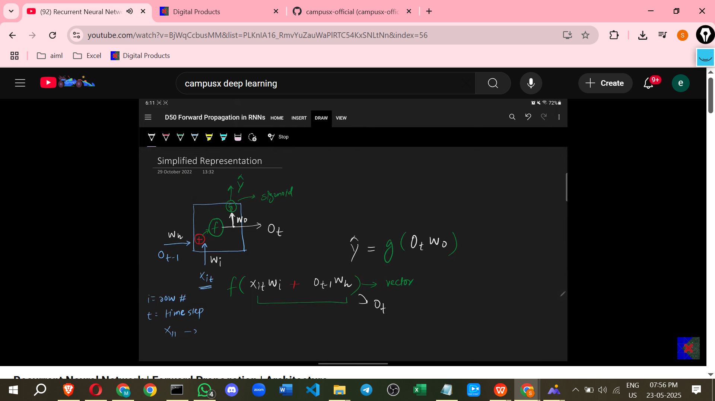

This forward propagation process allows the RNN to build up an understanding of the sequence step by step, using the "memory" passed through the recurrent connection. The next topic typically discussed is how backpropagation works in RNNs.

—-----------------------------

# **Class 3. RNN Sentiment Analysis | RNN Code Example in Keras |**

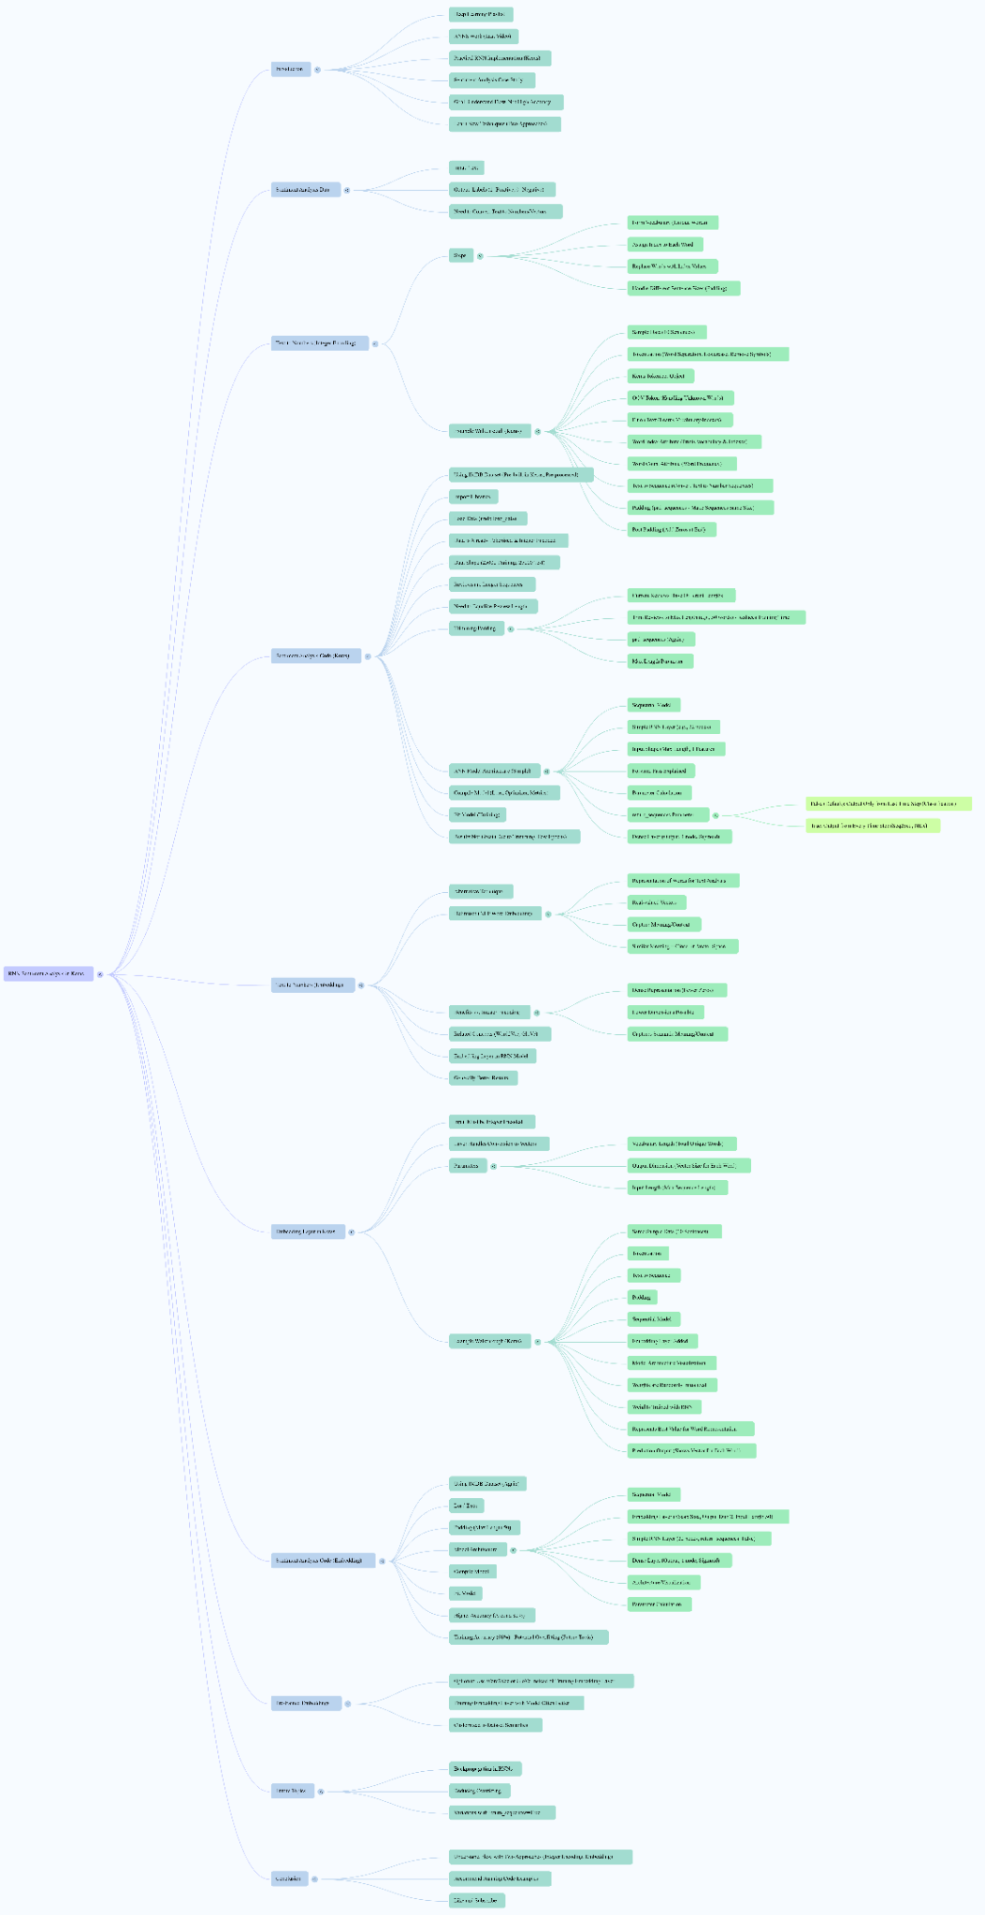

**implementing RNNs for sentiment analysis in Keras,**

**Video Overview**

* The video aims to demonstrate the practical implementation of Recurrent Neural Networks (RNNs) using Keras for sentiment analysis.
* The goal is not necessarily to achieve high accuracy or build the strongest model, but to explain the entire workflow of creating a sentiment analysis project using RNNs.
* Two different processes will be used and explained.

**General Workflow for Sentiment Analysis with RNNs**

* Typically, the dataset for sentiment analysis will have text as input and binary labels (1 for positive sentiment, 0 for negative sentiment) as output.
* The most crucial step is to convert the **text data into numbers or vectors** because neural networks only understand numbers.

**Approach 1: Integer Encoding and Padding**

* This is one technique used to convert text to numbers.
* **Steps Involved:**
  + **Form Vocabulary:** Identify all unique words in the entire document. For example, in "Hi there how are you", the unique words are "Hi", "there", "how", "are", "you".
  + **Assign Index Values:** Provide a unique integer index for each unique word in the vocabulary. For example, "Hi" = 1, "there" = 2, "how" = 3, "are" = 4, "you" = 5. The Keras Tokenizer automatically handles this, assigning indices based on word frequency (more frequent words get lower indices).
  + **Replace Sentences with Indices:** Replace the words in each sentence with their assigned index values. For example, "Hi there" becomes and "how are you" becomes. This results in sequences of numbers. The text_to_sequences method of the Keras Tokenizer is used for this.
  + **Handle Variable Sequence Sizes:** The resulting sequences often have different lengths. To feed this data to a neural network, all sequences must have the same size.

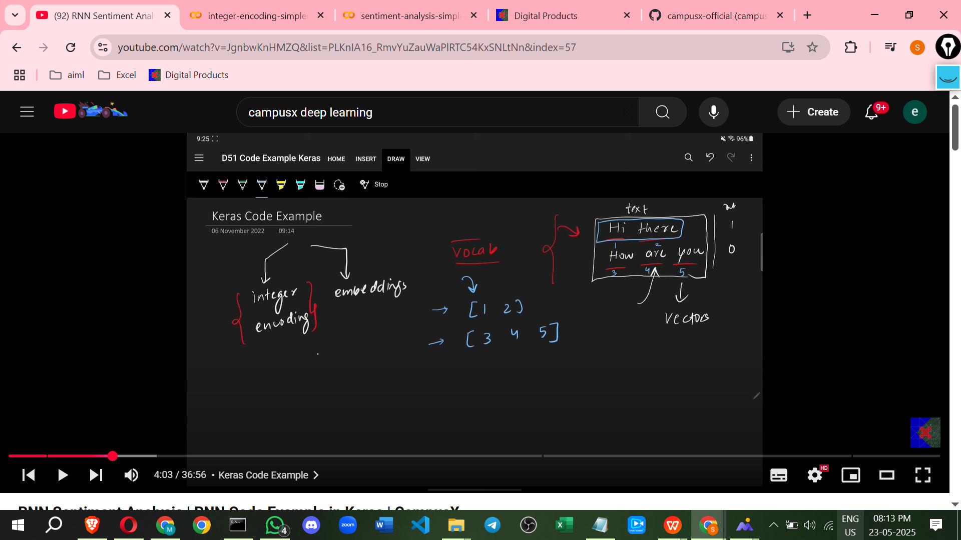

* + **Padding:** Apply padding (adding zeros) to the beginning or end of shorter sequences to match the length of the longest sequence, or a predefined maximum length. Keras provides the pad_sequences utility for this. Padding can be post (zeros added at the end) or pre (zeros added at the beginning).

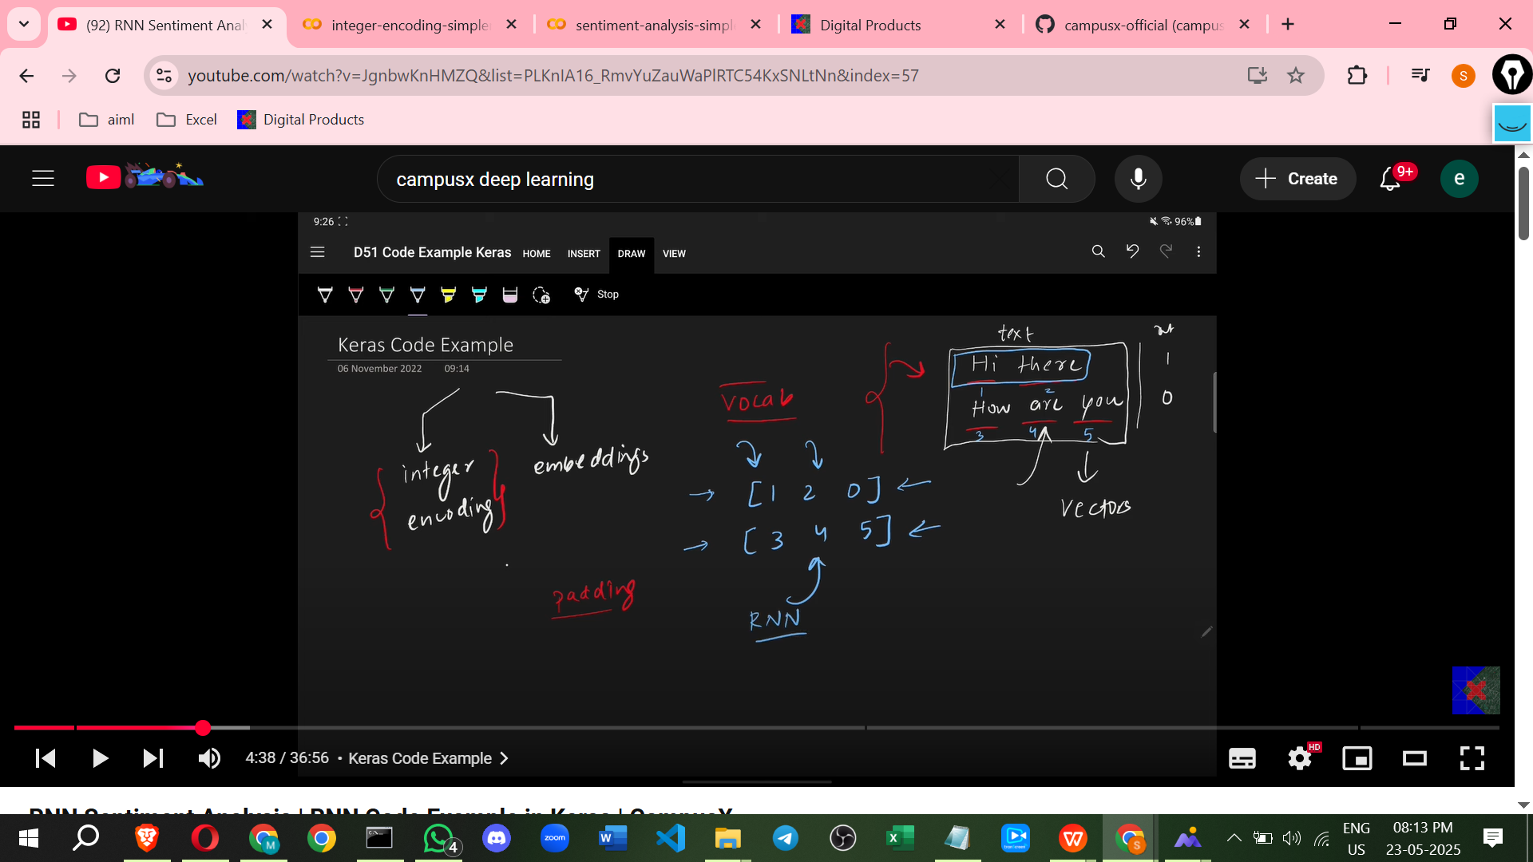

* + **Trimming:** Alternatively or in conjunction with padding, sequences can be trimmed to a maximum length, discarding words beyond that length. This is useful for large datasets or limited computational resources, though it results in loss of information.
* **Keras Implementation Details (using a simple document example):**[**Copy of sentiment-analysis-simplernn.ipynb**](https://colab.research.google.com/drive/10_9R1895luZay4QFjiRioaK6tEmJ5Mdh?usp=sharing)
  + Import Tokenizer from keras.preprocessing.text.
  + Create a Tokenizer object. The oov_token parameter handles out-of-vocabulary words (words in test data not seen during training) by replacing them with a special token (e.g., 'nothing').
  + Call fit_on_texts with the document to build the vocabulary and assign indices.
  + The Tokenizer object stores information like word_index (mapping words to indices) and word_counts (frequency of each word).
  + Call texts_to_sequences with the document to convert text sentences into sequences of integer indices.
  + Import pad_sequences from keras.preprocessing.sequence.
  + Call pad_sequences with the integer sequences and desired parameters (e.g., padding='post') to make all sequences the same length.
* **IMDB Dataset Example (pre-processed):** [**Copy of sentiment-analysis-simplernn.ipynb**](https://colab.research.google.com/drive/1GBezTaOzh4XyRQgeczwyKoFuJPynJAwy?usp=sharing)
  + The IMDB dataset is a pre-built dataset available in the Keras library.
  + It contains movie reviews and their sentiment labels.
  + The good part is that this dataset is already pre-processed and **integer-encoded**, saving the manual tokenization and integer encoding steps.
  + Load the data using imdb.load_data(). The data is split into training (x_train, y_train) and testing (x_test, y_test) sets.
  + The x_train and x_test arrays contain integer sequences representing the reviews. Each number in the sequence corresponds to a word index in a pre-built vocabulary.
  + The raw review text is not present; instead, you see sequences of integers.
  + Review lengths are variable.
  + Padding/Trimming is still necessary to ensure uniform input size. The example trims reviews to a maximum length of 50 words using pad_sequences(max_len=50, padding='post').
* **Building the RNN Model (Integer Encoding Approach):**

```

from keras.datasets import imdb

from keras.preprocessing.text import Tokenizer

from keras.utils import pad_sequences

from keras import Sequential

from keras.layers import Dense,SimpleRNN,Embedding,Flatten

``

* + Create a Sequential model in Keras.
  + Add a SimpleRNN layer.
  + Parameters for SimpleRNN:
    - Number of units (neurons), e.g., 32 nodes.
    - input_shape: Needs to specify the shape of the input sequences. For integer encoded data after padding/trimming, this is (sequence_length, 1), e.g., (50, 1) because each time step processes one integer (representing one word).
    - return_sequences: Controls the output of the RNN layer.
      * False (default): Outputs only the hidden state from the *last* time step. This is suitable for sequence classification tasks like sentiment analysis where you need a single output representing the whole sequence.
      * True: Outputs the hidden state from *each* time step. This is useful for tasks where you need an output for every input word, like Named Entity Recognition or Machine Translation.
  + Add a final Dense layer for classification. For binary sentiment analysis, this would typically have 1 unit and a sigmoid activation function.
  + **Compilation:** Configure the model for training using model.compile(). Specify the loss function (e.g., binary_crossentropy for binary classification), an optimizer (e.g., adam), and metrics to evaluate (e.g., accuracy).
  + **Fitting:** Train the model using model.fit() with the training data (x_train, y_train).
  + The example notes that accuracy might not be very high (e.g., around 50-60%) potentially due to trimming reviews to only 50 words and not training for many epochs.

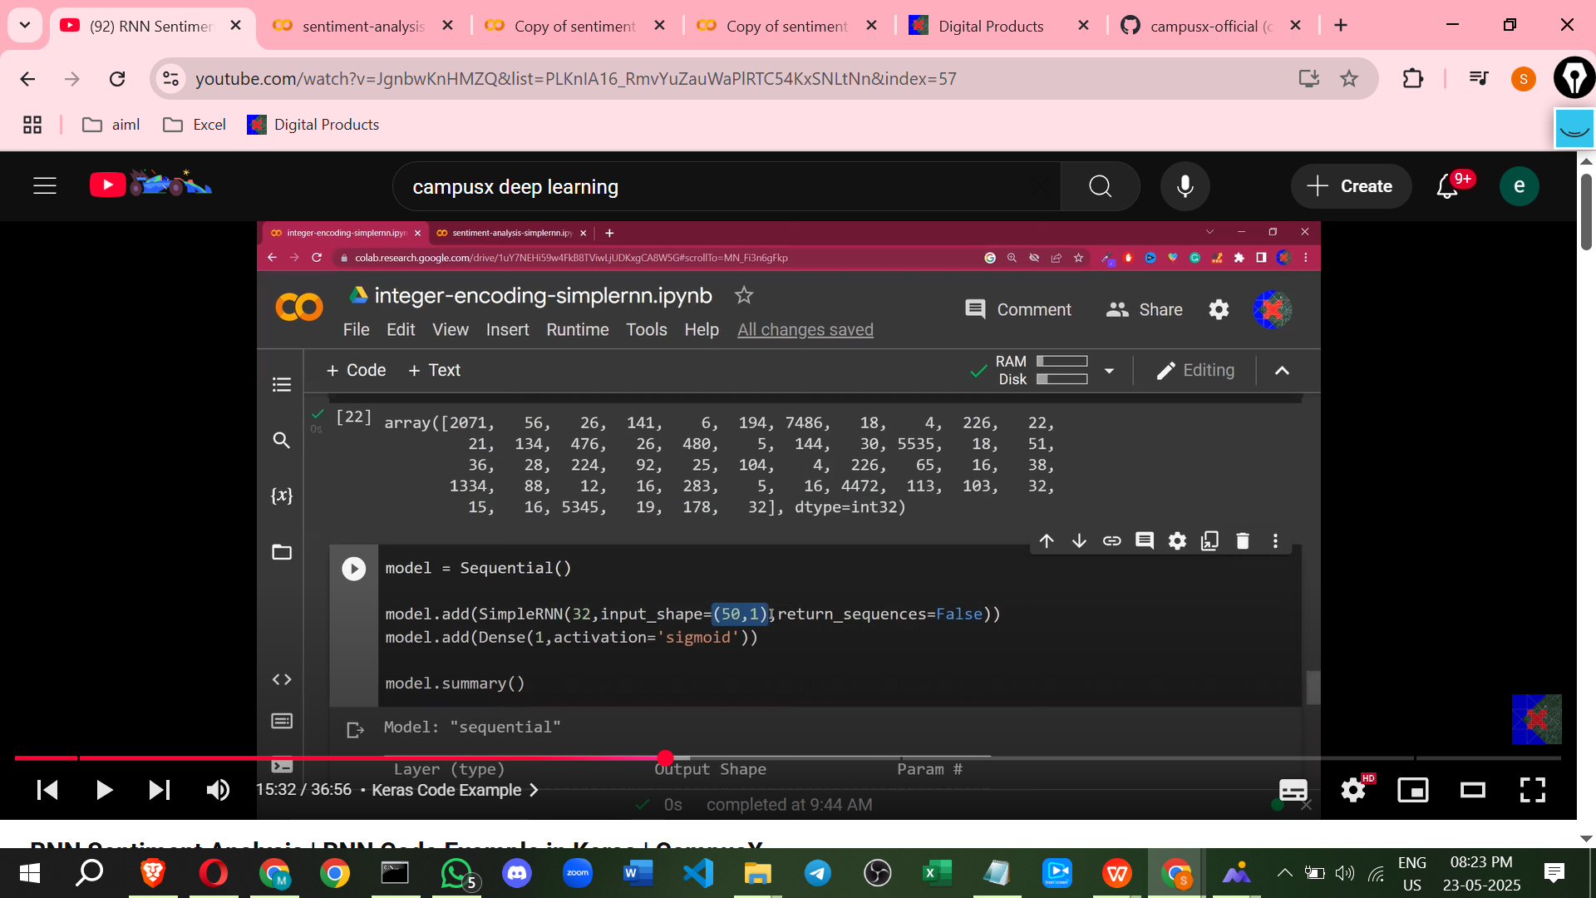

**Approach 2: Word Embedding**

* **What is Word Embedding?**
  + It is a technique for representing words or text analysis, typically as **real-valued dense vectors(non-zero most value reduce)**.
  + 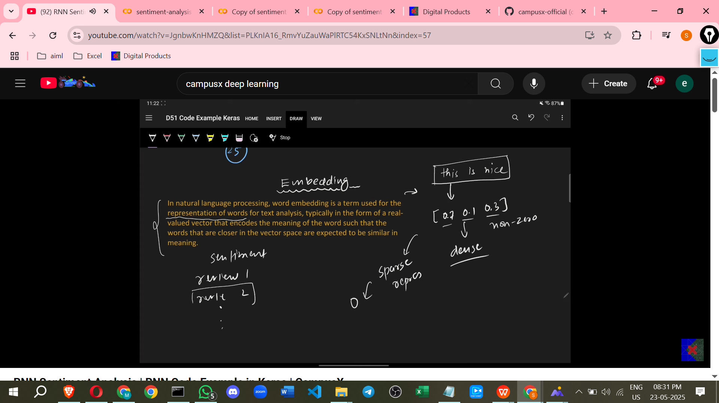
  + These vectors are designed to capture the meaning (semantics) of words.
  + The core idea is that words with similar meanings are located **closer** to each other in the vector space.

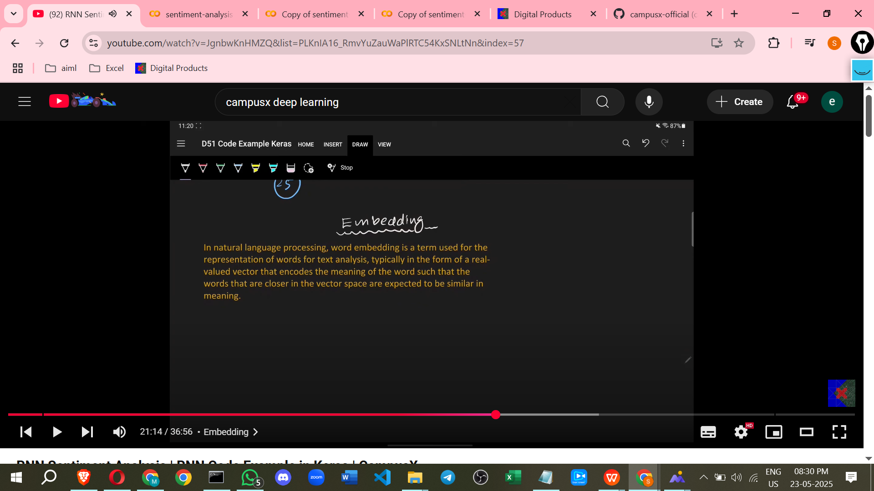

* **Benefits Compared to Sparse Representations (like simple integer encoding or one-hot encoding before embedding):**
  + **Dense Representation:** Most values in the vector are non-zero, unlike sparse representations where many values are zero (e.g., padding zeros or one-hot vectors). This leads to **lower dimensionality** compared to sparse methods when representing a vocabulary (e.g., 32 dimensions vs. 2000 dimensions or vocabulary size).
  + **Captures Semantic Meaning:** Embeddings understand the context in which a word is used. This ability to capture semantic relationships allows for the development of better models. Words closer in the vector space are expected to have similar meanings.
  + Related to techniques like Word2Vec and GloVe.
* **Keras Embedding Layer:**
  + Instead of **manually creating embeddings or using external ones**, Keras provides an Embedding layer that can be the first layer in your model.
  + This layer automatically learns the embeddings during the model's training process.

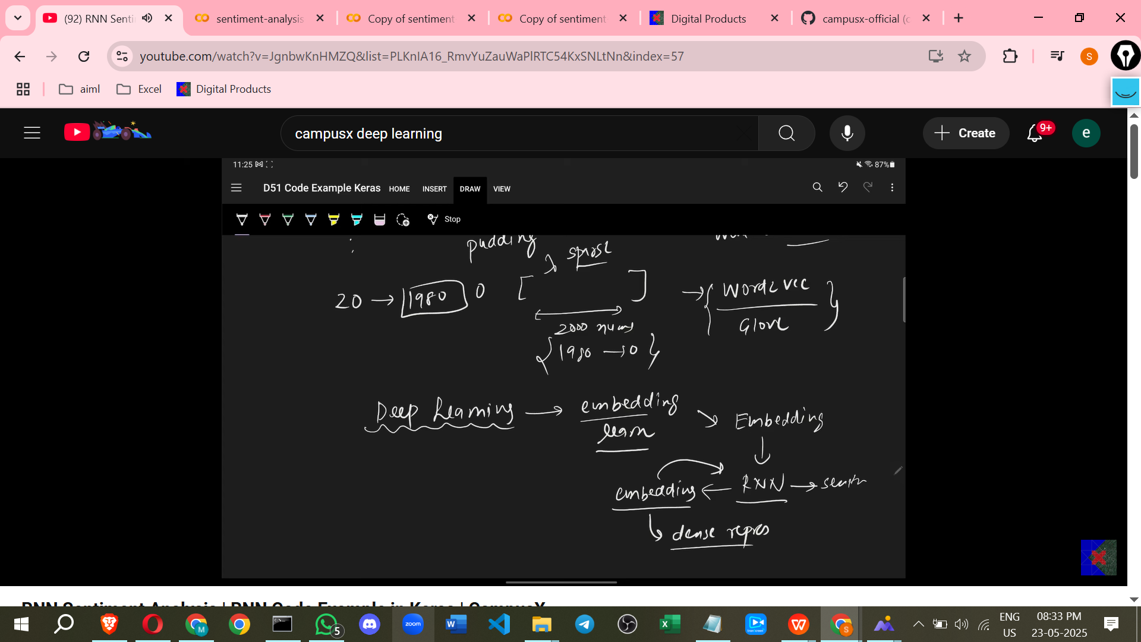

* + The **input** to the Embedding layer *must* be **integer-encoded** sequences. The Embedding layer handles everything else internally.
* **Implementing with Keras Embedding Layer:**
  + Start with integer-encoded, padded sequences as the input data, just like in the first approach.
  + Create a Sequential model.
  + Add an Embedding layer as the first layer.
  + Parameters for Embedding:
    - input_dim: The size of the vocabulary (total number of unique words + 1, often including a reserved index for padding or out-of-vocabulary tokens). This is the total number of possible input integers.
    - output_dim: The dimension of the dense vector representation for each word. This determines the size of the embedding vectors you want to learn (e.g., 2, 32, 100).
    - input_length: The length of your input sequences after padding/trimming. This is the number of words/integers in each input sample.
  + **How it works:** The Embedding layer can be thought of as a layer that takes an integer index as input and outputs the corresponding learned embedding vector. Internally, it uses a matrix where rows correspond to word indices and columns are the dimensions of the embedding vectors. This matrix's values (the embeddings) are randomly initialised and then **learned** during training along with the rest of the model.
  + When you pass a sequence of integer indices (a padded review) to the Embedding layer, it outputs a sequence of embedding vectors. If your input sequence has length L and your embedding dimension is D, the output shape will be (L, D).

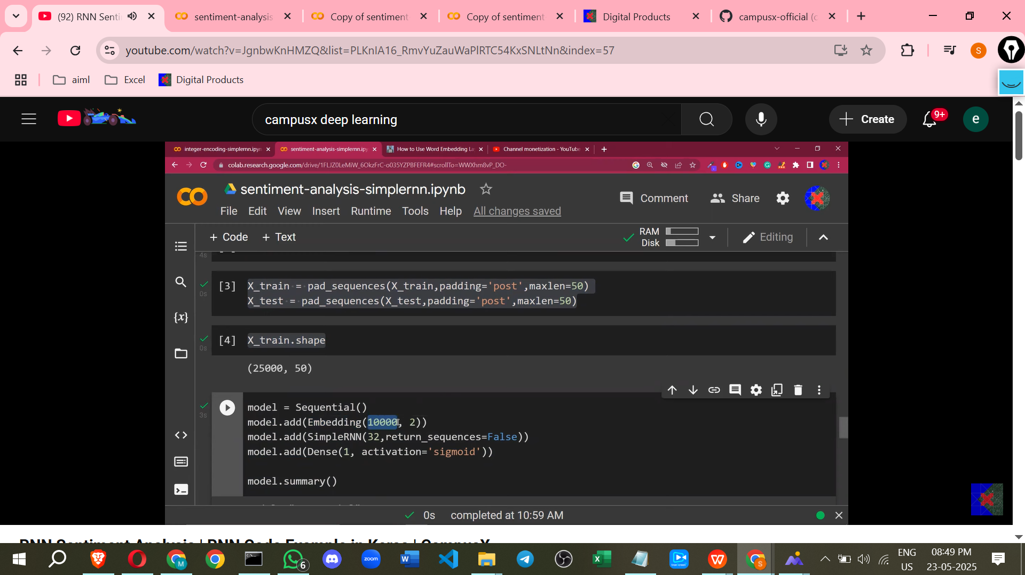

* + **Building the full model (Embedding Approach):**
    - Create a Sequential model.
    - Add an Embedding layer first. Specify input_dim (vocabulary size, e.g., 10000), output_dim (embedding vector size, e.g., 32), and input_length (padded sequence length, e.g., 50).
    - Add a SimpleRNN layer after the Embedding layer. The output of the Embedding layer becomes the input to the RNN layer. The input_shape for the RNN is implicitly handled by Keras when it follows an Embedding layer, taking the input_length and output_dim of the Embedding layer.
    - Set return_sequences=False on the RNN for classification.
    - Add a final Dense layer with 1 unit and sigmoid activation for binary classification.
    - Compile and fit the model as before.

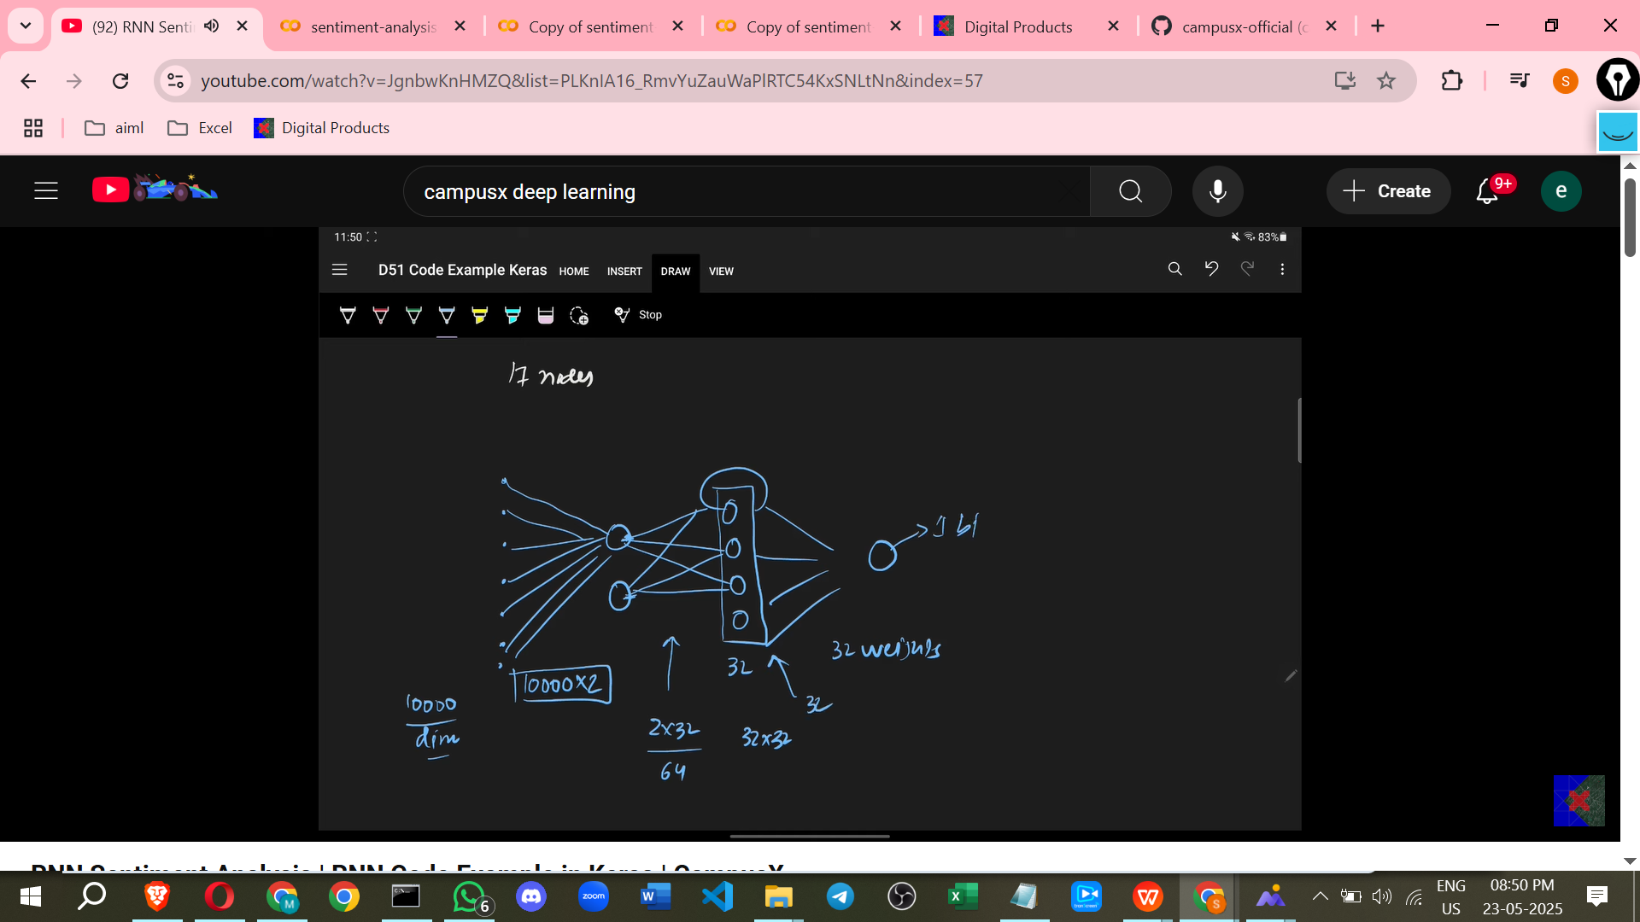

* **Comparison and Results:**
  + The example shows that the Embedding approach using the IMDB dataset achieves potentially higher accuracy (around 80% training accuracy) compared to the simple integer encoding without embedding.
  + Training embeddings as part of the model is generally beneficial because the generated embeddings are tailored (more custom) to the specific dataset and can better capture its semantic meaning.
  + Alternatively, you can use pre-trained embeddings like Word2Vec or GloVe.

**Further Notes**

* The SimpleRNN layer processes input one time step at a time. The output from a previous time step and the current input are used to calculate the current output.
* The number of parameters in an RNN layer depends on the number of input features, the number of units, and biases.
* Overfitting (high training accuracy but lower validation/test accuracy) is a potential issue that can be addressed later.
* The next video in the series will cover backpropagation in RNNs.
* It is recommended to run the code yourself to gain confidence.

============================================================

# **Class 4. Types of RNN | Many to Many | One to Many | Many to One RNNs**

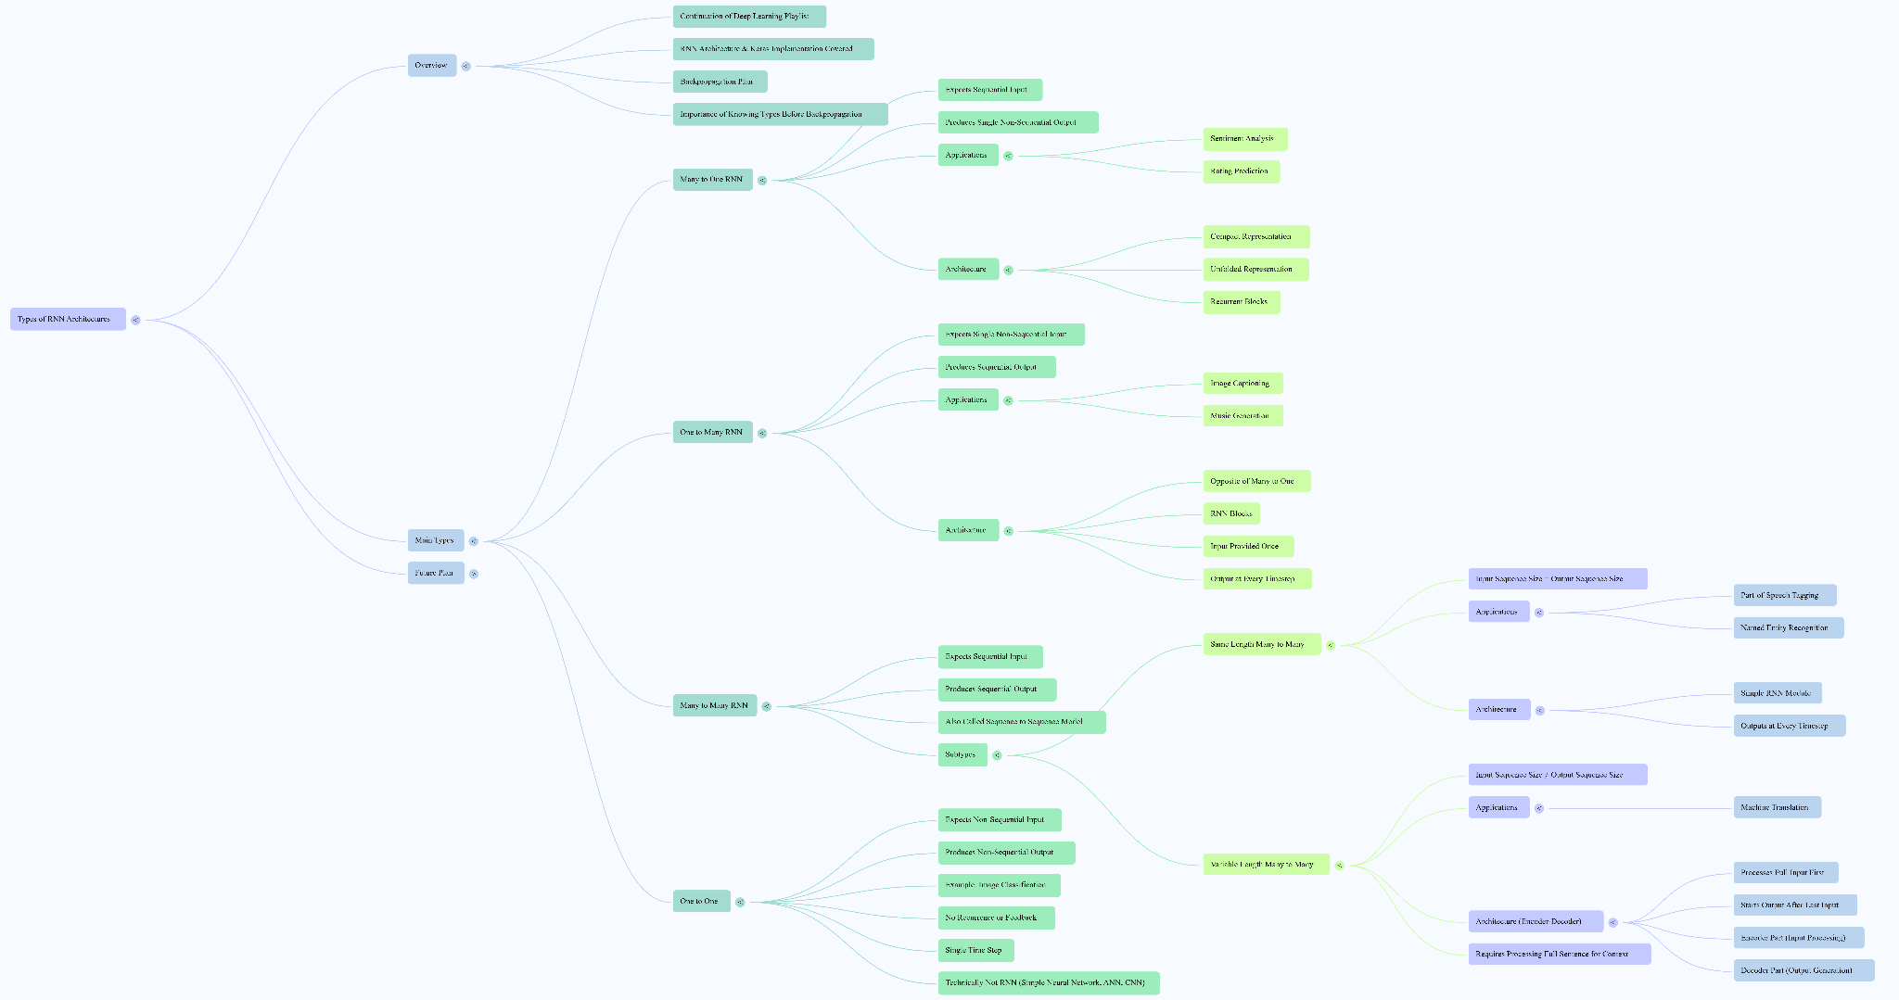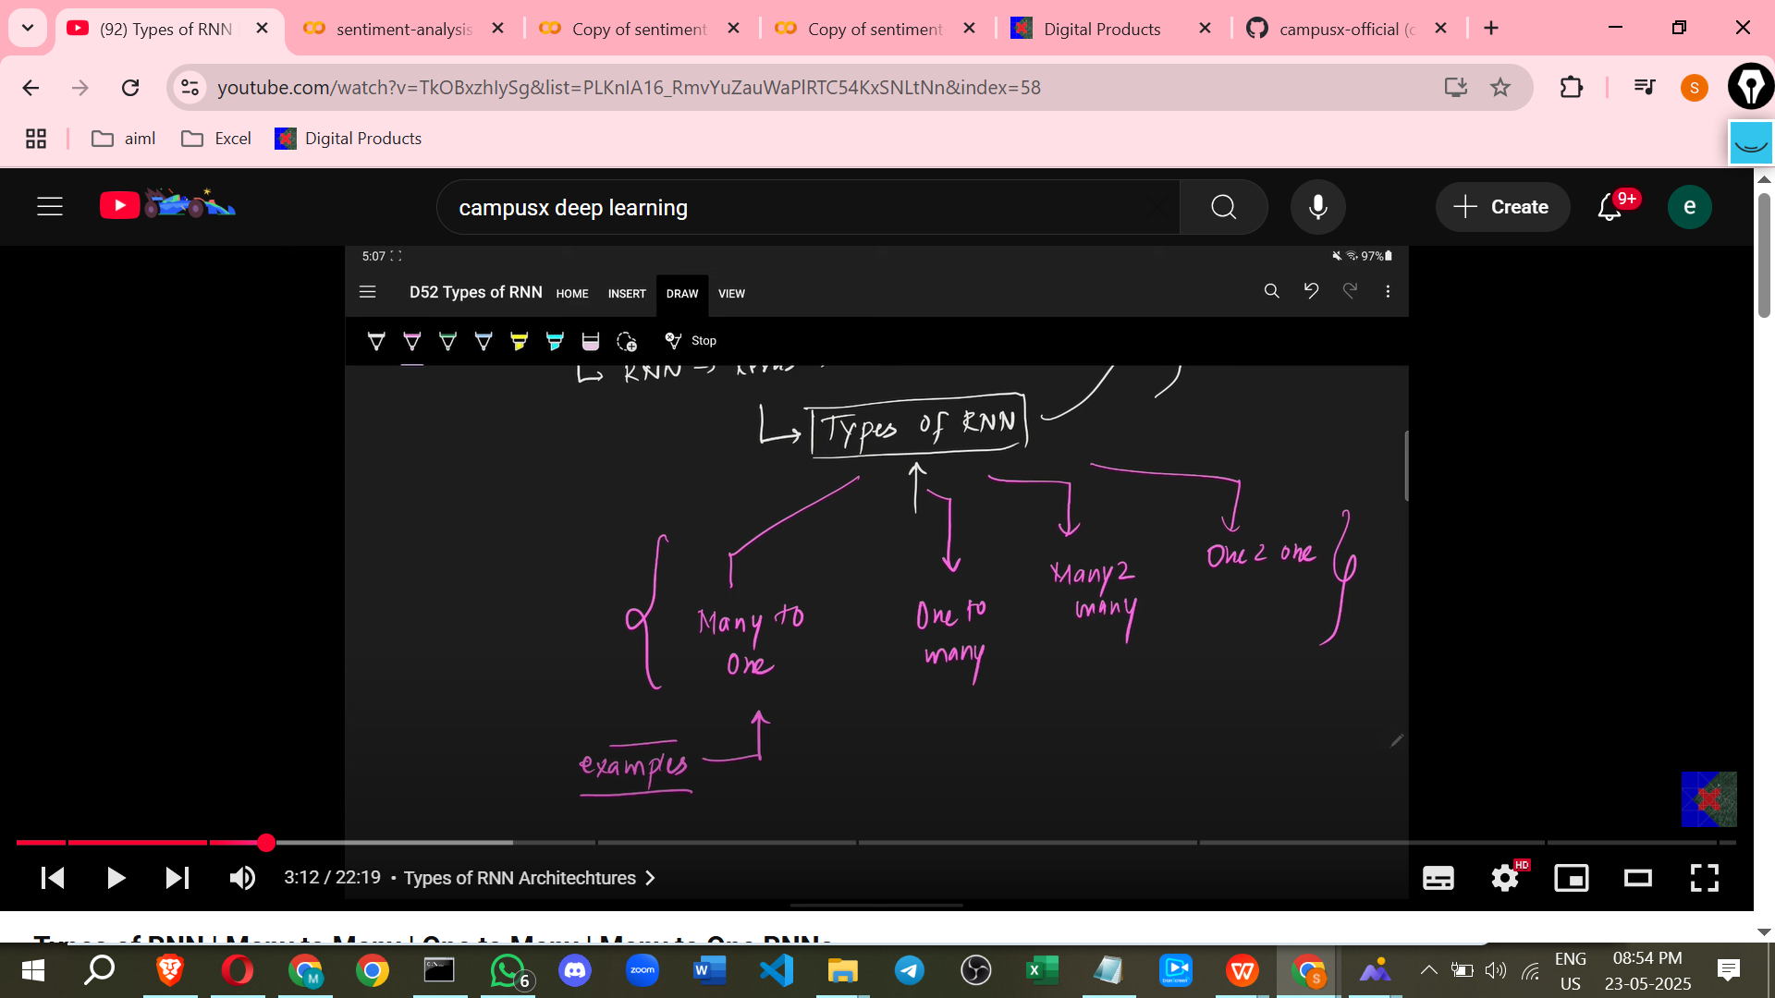

There are considered to be **four main types of RNN architectures**:

1. Many-to-One
2. One-to-Many
3. Many-to-Many
4. One-to-One

Let's discuss each type in detail.

* **Many-to-One RNNs**
  + **Input/Output:** This architecture expects a **sequence of data as input** but produces a **single, non-sequential output**. The name "Many-to-One" reflects this: many inputs (the sequence) lead to one output.
  + **Use Cases:** This type is suitable for applications where you process a sequence to arrive at a single conclusion or prediction.
    - **Sentiment Analysis:** A common example where the input is a sequence of words (a text review), and the output is a single value indicating the sentiment (e.g., 1 for positive, 0 for negative). This is a task you have already worked on with Keras implementation.
    - **Rating Prediction:** Similar to sentiment analysis, you might take a movie review (a sequence of text) and predict a single star rating between 1 and 5.
    - *Extra Detail (not in source):* Other potential use cases include classifying time series data (e.g., detecting an anomaly in a sensor reading sequence) or predicting the category of an audio clip.
  + **Architecture:** The basic RNN block processes inputs sequentially. The input at each time step is fed into the block, along with feedback from the previous time step's hidden state. An output is calculated at each time step, but the final prediction (the 'one' output) is typically made only at the **very last time step** after processing the entire input sequence.
    - *Compact Representation:* A single RNN block where the sequence goes in and a single output comes out at the end.
    - *Unfolded Representation:* Shows the sequence being fed word by word over several time steps (t=0, t=1, t=2, ...). The output is calculated at each step, but the main prediction is shown only after the last word is processed. The recurrent block involves the input, the previous time step's input, applying an activation function, and getting the current time step's output which is fed back.

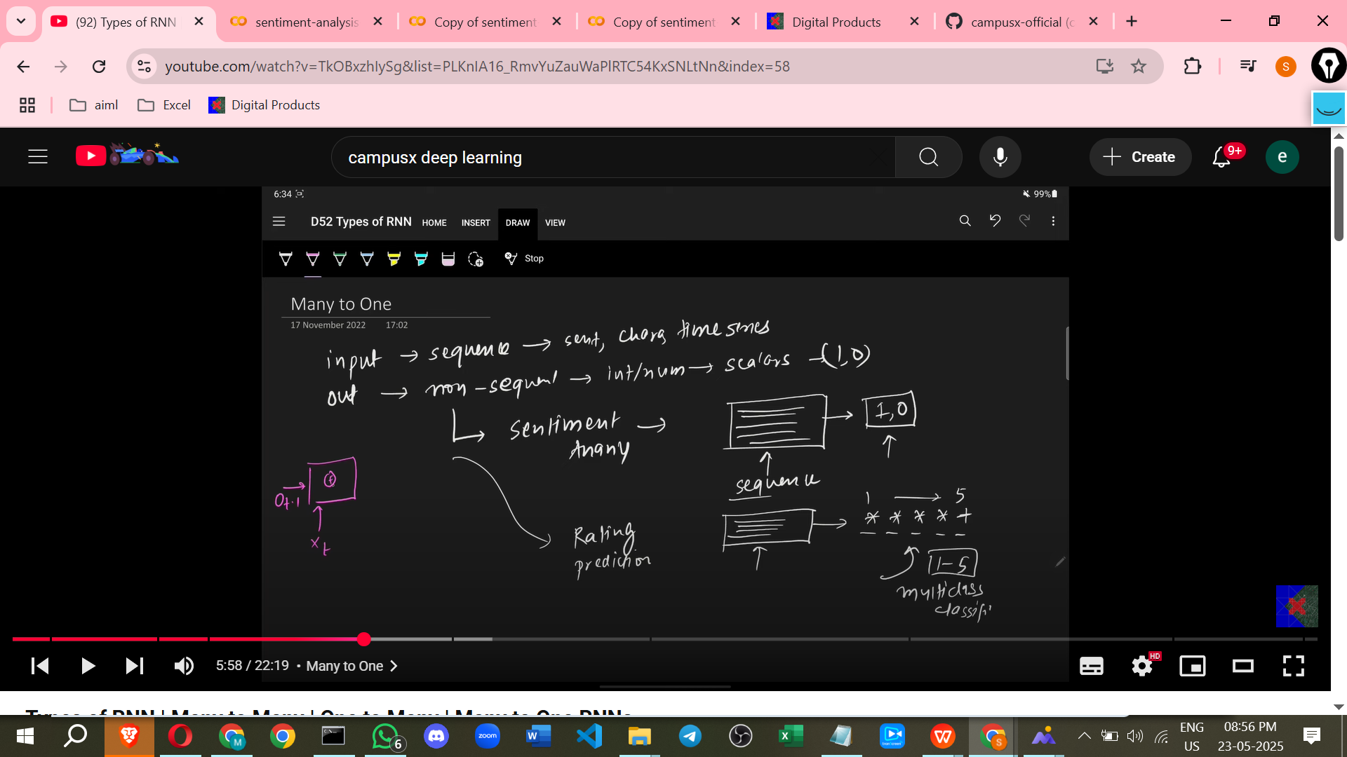

* **One-to-Many RNNs**
  + **Input/Output:** This architecture works in the opposite way to Many-to-One. It takes a **single, non-sequential data point as input** and generates a **sequence of data as output**.
  + **Use Cases:** This type is useful when you have a single piece of information that needs to be expanded into a sequence.
    - **Image Captioning:** A prominent example used in the industry. An image (non-sequential data) is fed into the network, and the output is a textual description (a sequence of words) of the image content. For instance, feeding an image of someone playing cricket could result in the output sequence "A man is playing cricket".
    - **Music Generation:** Inputting a single seed value or note can lead the network to generate a sequence of musical notes, creating a piece of music.
    - *Extra Detail (not in source):* Text generation starting from a single word or character (predicting the next word/character based on the previous one generated by the network) is another application. Video generation from a single image could also potentially fall into this category.
  + **Architecture:** RNN blocks are used, but the input is provided only once at the beginning. After this initial input, the network generates an output at each subsequent time step. This output is also fed back into the network for the next time step, allowing the generation of a sequence.

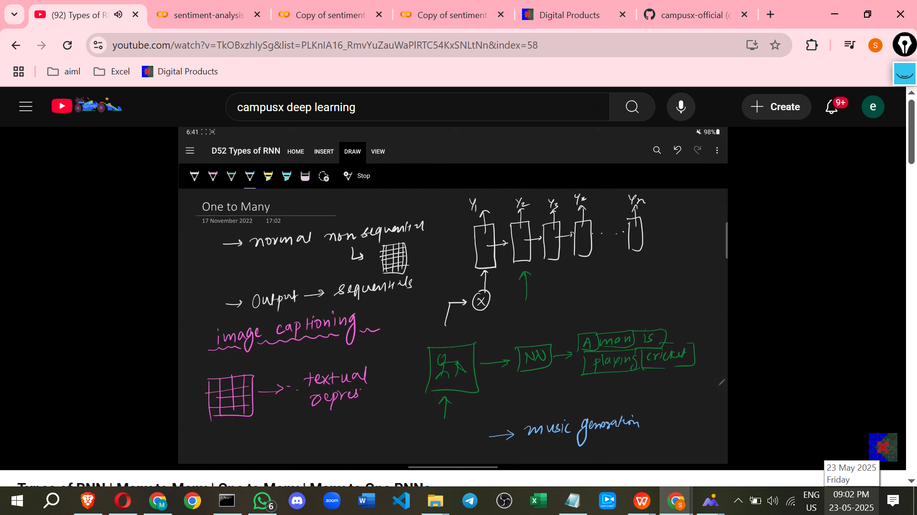

* **Many-to-Many RNNs**
  + **Input/Output:** This is considered a very interesting type where both the **input and the output are sequences**. Due to this characteristic, they are often referred to as **Sequence-to-Sequence models**. The source indicates that this type will be worked on extensively in the future.
  + **Subtypes:** Many-to-Many RNNs can be divided into two categories based on the length of the input and output sequences:
    - **Same Length Many-to-Many:**
      * **Input/Output Relationship:** The size or length of the input sequence is **the same as** the size or length of the output sequence.
      * **Use Cases:** Tasks where you need to process a sequence and produce an output sequence of the same length, often with a direct correspondence between input and output elements.
        + **Parts of Speech Tagging:** For every word in an input sentence (e.g., "This is a noun"), the output is a sequence of tags indicating the part of speech for each word ("This is a noun" -> "Determiner is a noun").
        + **Named Entity Recognition:** Another popular task where, for each word in an input sentence, the model decides whether it is part of a named entity (like a person's name, location, or organisation) or not. For instance, "Let's meet at 7:00 PM at the Airport".
        + *Extra Detail (not in source):* Character-level translation or transformation (e.g., spelling correction, although more complex models are often used) could sometimes fit this model if the input/output lengths are expected to be the same.
      * **Architecture:** Similar to the unfolded simple RNN, inputs are fed sequentially, and an output is generated at **every time step**. The output from one step is fed back into the network for the next step, along with the next input in the sequence. Inputs are denoted as x_t and outputs as y_t.

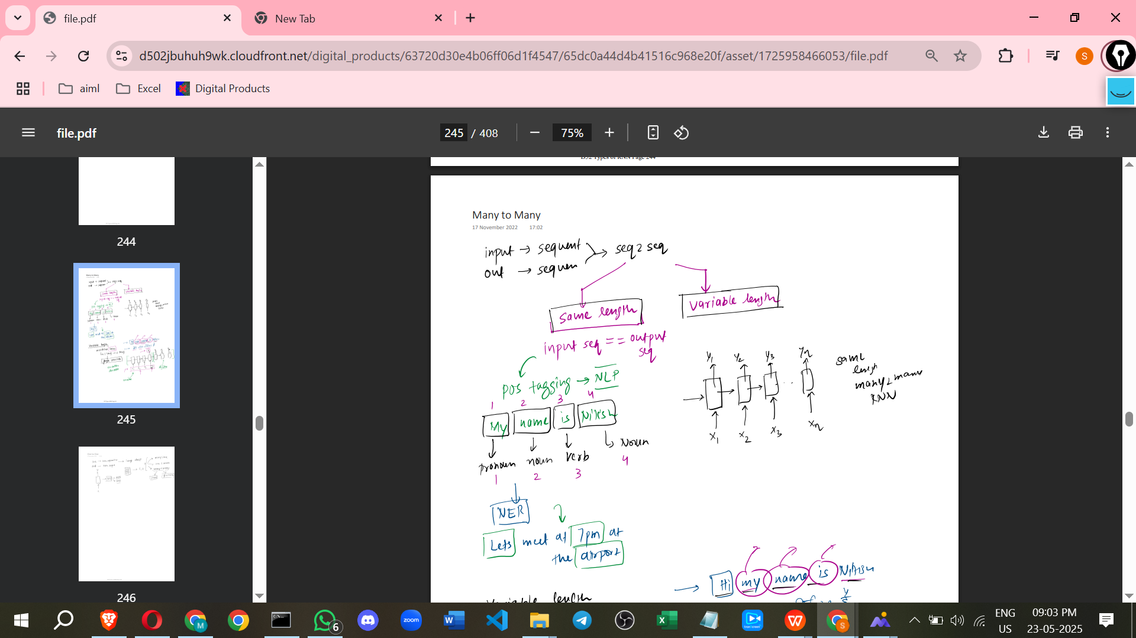

* **Variable Length Many-to-Many:**

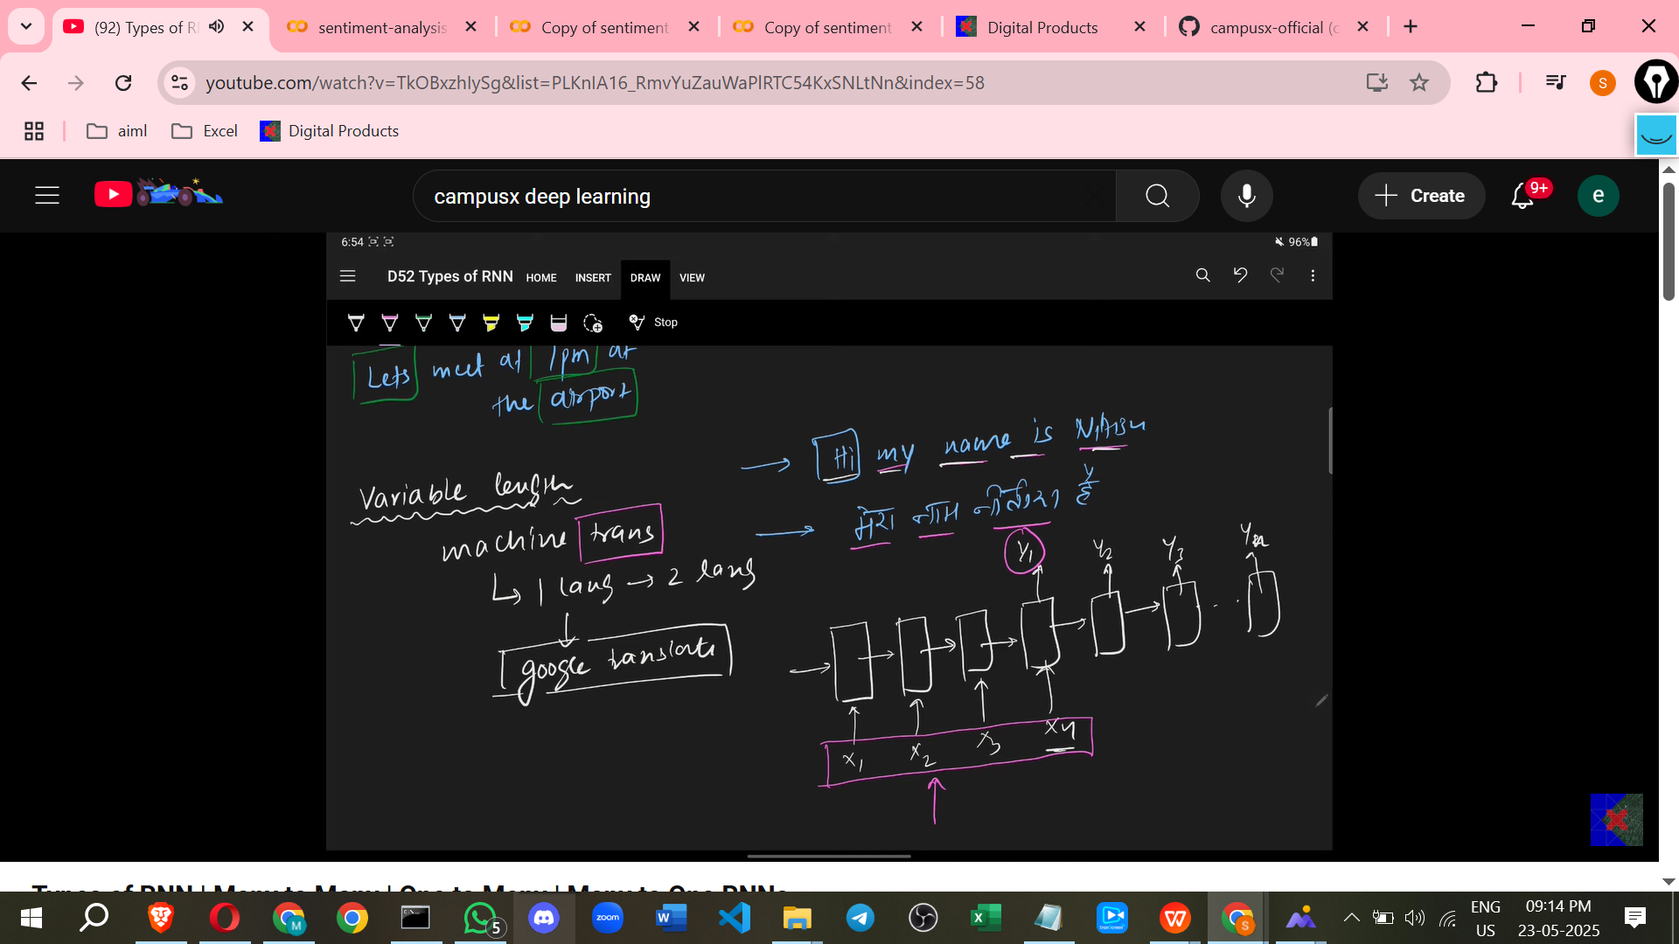

* + **Input/Output Relationship:** The length of the input sequence is **different from** the length of the output sequence. It's not guaranteed that the number of words in the input language will equal the number of words in the output language during translation.
  + **Use Cases:** Tasks where the output sequence length is not directly dependent on the input sequence length.
    - **Machine Translation:** A prime example where a sentence in one language (input sequence) is translated into a sentence in another language (output sequence). For example, translating "Hi, my name is Nitish" to "मेरा नाम नीतीश है" might involve a different number of words. This is a good example because different languages represent sentences with varying efficiency.
    - *Extra Detail (not in source):* Chatbots often use a variable length Many-to-Many structure where the user's input sentence is the input sequence, and the bot's response (which can be shorter or longer) is the output sequence. Speech recognition (audio sequence to text sequence) or text summarization (long text sequence to short summary sequence) are other examples.
  + **Architecture:** This architecture typically consists of two main parts: an **Encoder** and a **Decoder**.
    - **Encoder:** The first part, where you feed the **entire input sequence first**. It processes the whole input (e.g., all words in the source sentence) before any output is generated.
    - **Decoder:** The second part, which **starts generating the output sequence** *only after* the entire input has been processed by the encoder. The output sequence (y1, y2, y3, ...) is produced step by step.
  + **Reasoning for the Architecture:** This two-part structure is logical for tasks like translation because translating involves understanding the **entire input sentence** – its meaning, grammar, and context – before deciding on the translation in the target language. Translating word by word without considering the whole sentence would likely lead to a loss of grammatical meaning and context.
* **One-to-One RNNs**
  + **Input/Output:** This type expects **non-sequential data as input** and produces **non-sequential data as output**.
  + **Use Cases:** Simple classification or regression tasks where there's no inherent sequence in the data.
    - **Image Classification:** Input is an image (non-sequential), and the output is a single label (e.g., 1 or 0 for cat/not cat).
    - *Extra Detail (not in source):* Predicting the price of a house based on its features (number of rooms, size, location - non-sequential inputs) is another example.
  + **Architecture:** The input is given, and the output is produced in a single step. There is **no recurrence or feedback loop**. No time steps are involved in the sense of processing a sequence over time.
  + **Technical Clarification:** Technically speaking, this One-to-One architecture is **not an RNN**. It is a **simple neural network** like an Artificial Neural Network (ANN) or a Convolutional Neural Network (CNN). This type is mentioned just to provide perspective on when RNNs are used and when they are not.

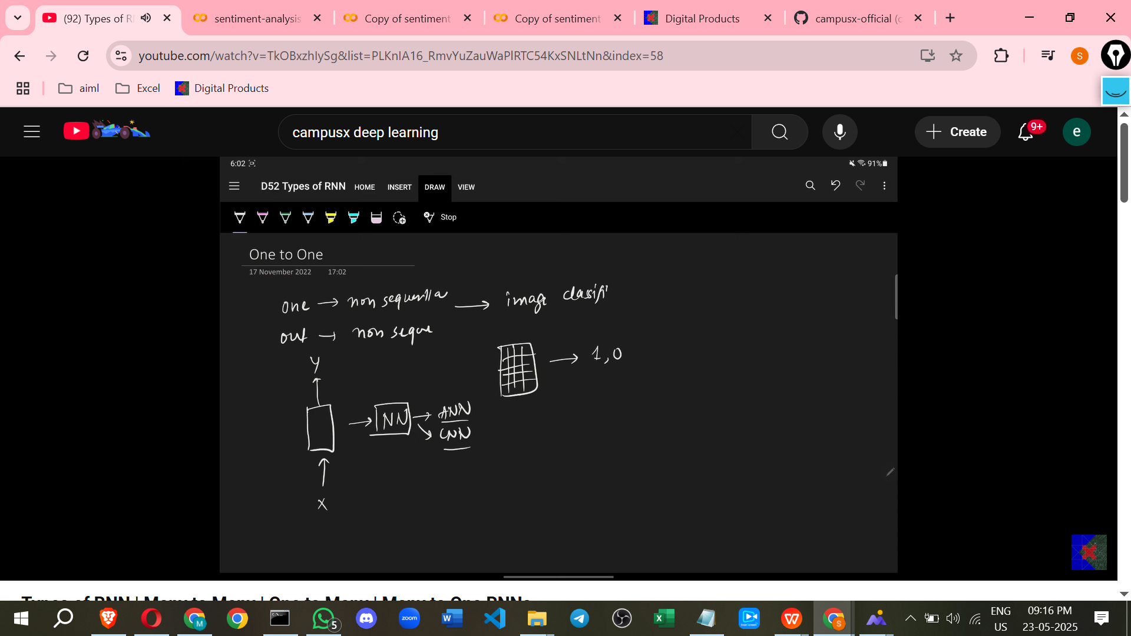

**Summary of Technical RNN Types:**

Technically, there are only **three main types of RNN architectures**:

1. Many-to-One
2. One-to-Many
3. Many-to-Many (which has two subtypes: Same Length and Variable Length).

**Looking Ahead:**

The next video in the series plans to cover **backpropagation** and explain how it works for these three technical RNN architectures. Following that, the focus will shift to working with the **Many-to-Many** (Sequence-to-Sequence) architecture, including the Encoder-Decoder networks.

=====================================================================

# **Class 5. How Backpropagation works in RNN | Backpropagation Through Time**

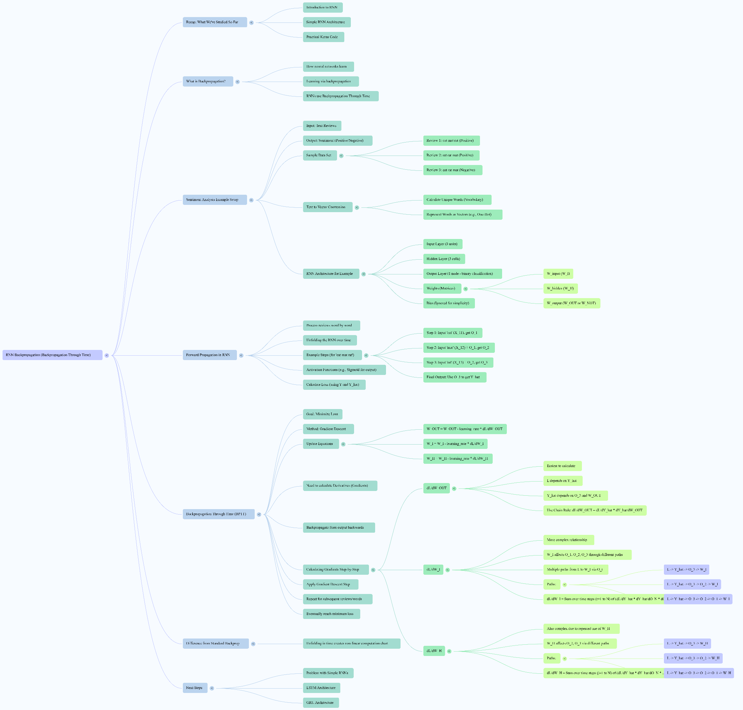

how backpropagation works in Recurrent Neural Networks (RNNs), also known as Backpropagation Through Time (BPTT), based on the information in the sources.

**Introduction**

* In neural networks, **learning occurs through backpropagation**.
* In RNNs, the backpropagation process is specifically called **Backpropagation Through Time (BPTT)**.

**Why Backpropagation Through Time (BPTT)?**

* The term "Through Time" is used because the recurrent nature of the RNN means that the network is **unfolded in time** to perform calculations. This unfolding creates a computational graph that spans across the time steps of the input sequence.
* To calculate the gradients needed for weight updates, backpropagation has to propagate **backwards through this unfolded graph**, across all the time steps.

**Setup Example (Sentiment Analysis)**

* The source uses an example of sentiment analysis as a problem where RNNs can be applied.
* In sentiment analysis, the input is text, and the output indicates the sentiment (e.g., 1 for positive, 0 for negative for a binary classification problem).
* A **small toy dataset** is used with three example reviews.
  + Review 1: "cat cat cat" (positive sentiment).
  + Review 2: "rat rat mat" (negative sentiment).
  + Review 3: "cat rat mat" (negative sentiment).

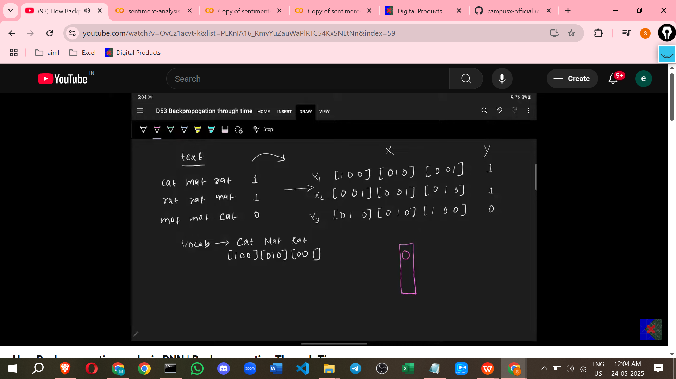

* To process the text, words are **converted into vectors (numbers)**. This involves creating a vocabulary of unique words and representing each word with a unique vector (e.g., using one-hot encoding).
  + Example: "cat" represented by, "mat" by, "rat" by based on the vocabulary of "cat", "mat", "rat".
* The RNN architecture for this example includes:
  + Input layer with 3 units (matching the dimensionality of the word vectors).
  + A recurrent hidden layer with 3 cells/units.
  + An output layer with 1 node (for binary classification).
* The network has **three main weight matrices**:
  + **W_input (W_I)**: Connects the input layer to the hidden layer.
  + **W_hidden (W_H)**: Connects the hidden layer's output at one time step to the hidden layer's input at the next time step (the recurrent connection).
  + **W_output (W_O)**: Connects the hidden layer's output to the output layer.
* Bias terms are mentioned but ignored for simplicity in the explanation.

**Forward Propagation in Unfolded RNN**

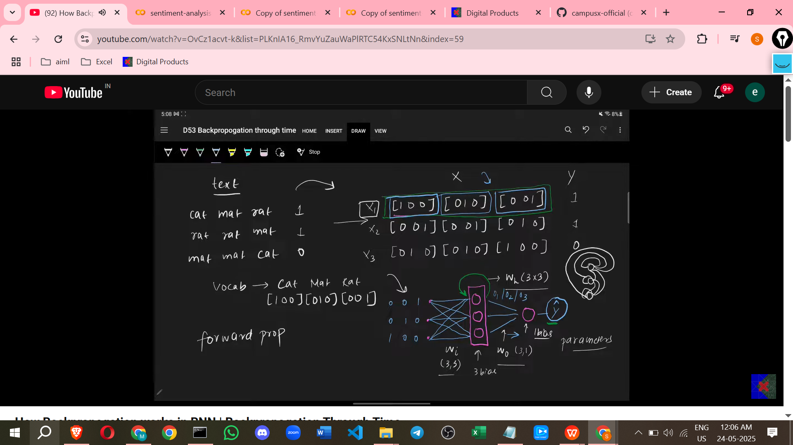

* Input reviews are processed **word by word**.
* The RNN is **unfolded across time steps**, one step for each word in the review. For a review with three words, the network is unfolded into three time steps.
* At each time step t, the network receives the current word's vector input (X_t) and the hidden state from the previous time step (H_t-1, where H_0 is initialised, often to zeros).
* The hidden state at the current time step (H_t) is calculated based on the current input (X_t), the previous hidden state (H_t-1), the input weight matrix (W_I), and the hidden weight matrix (W_H). An activation function is applied.
  + Equation structure: H_t = f(X_t * W_I + H_t-1 * W_H).
* For the example review "cat cat cat" (X1), the forward pass proceeds:
  + **Step 1**: Input X11 (vector for the first "cat") is fed in, along with initial hidden state (O0). O1 is calculated.
  + **Step 2**: Input X12 (vector for the second "cat") is fed in, along with O1 from the previous step. O2 is calculated.
  + **Step 3**: Input X13 (vector for the third "cat") is fed in, along with O2 from the previous step. O3 is calculated.
* After processing all words, the **final hidden state** (O3 in the example) is used to calculate the final output (y_hat).
  + Equation structure: y_hat = g(O_N * W_O), where N is the number of words, and g is the output activation function (e.g., sigmoid for binary classification).

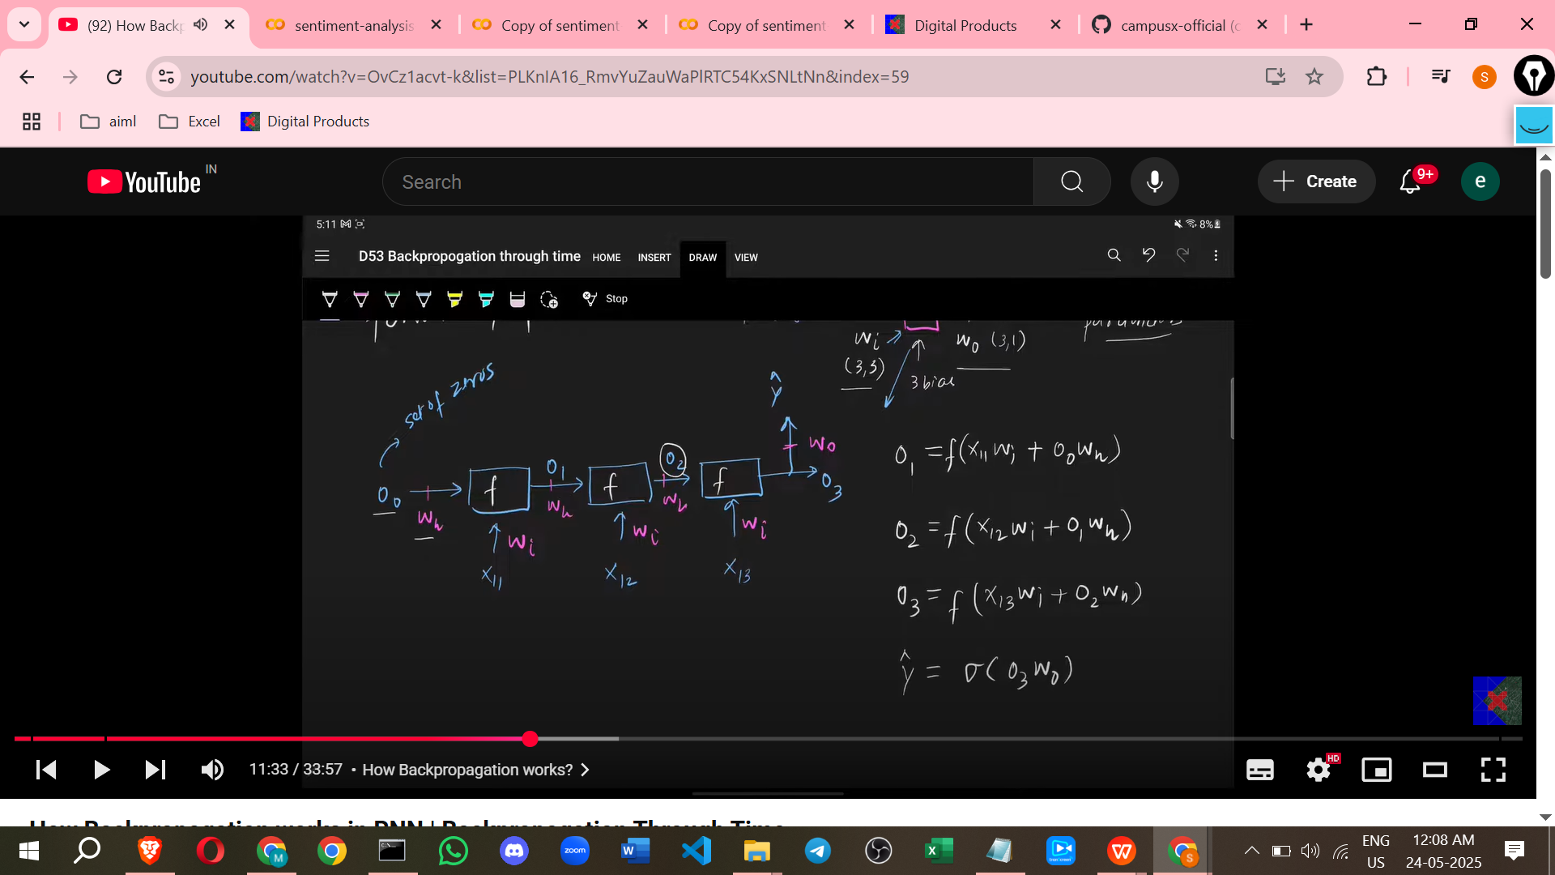

**Loss Calculation**

* Once y_hat is calculated, the **loss** is computed by comparing y_hat with the actual target value (y).
* For a binary classification problem like sentiment analysis, **binary cross-entropy** is typically used as the loss function.
  + Loss equation structure: L = -y log(y_hat) - (1-y) log(1-y_hat).

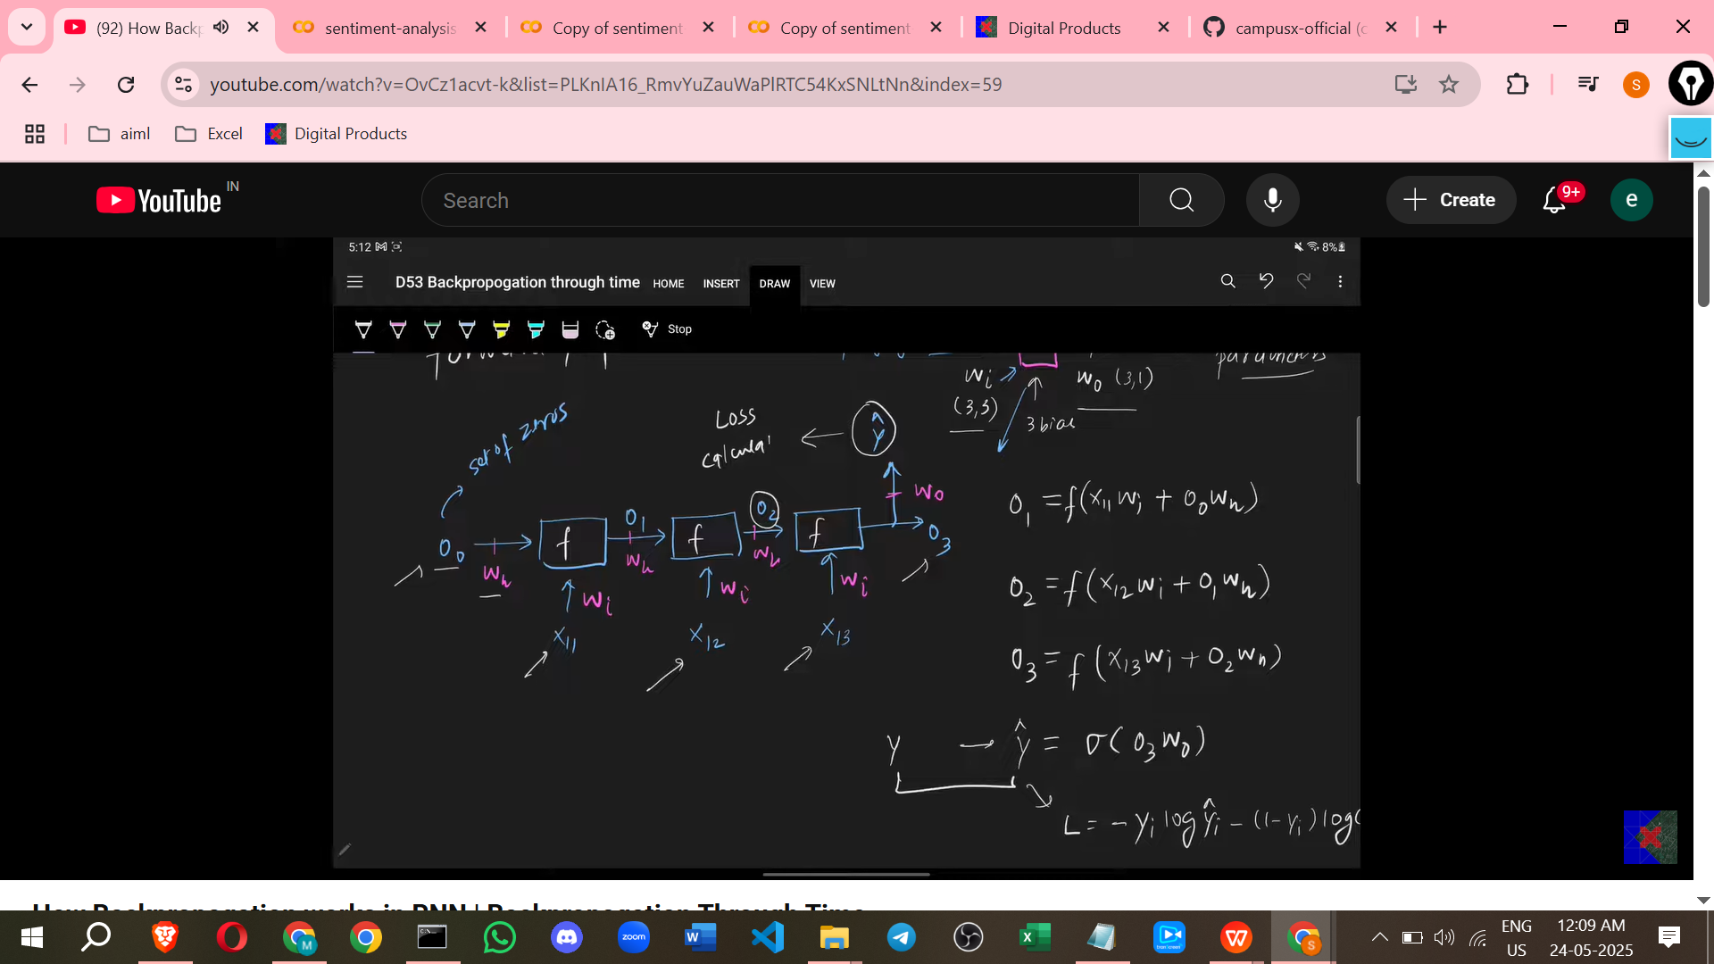

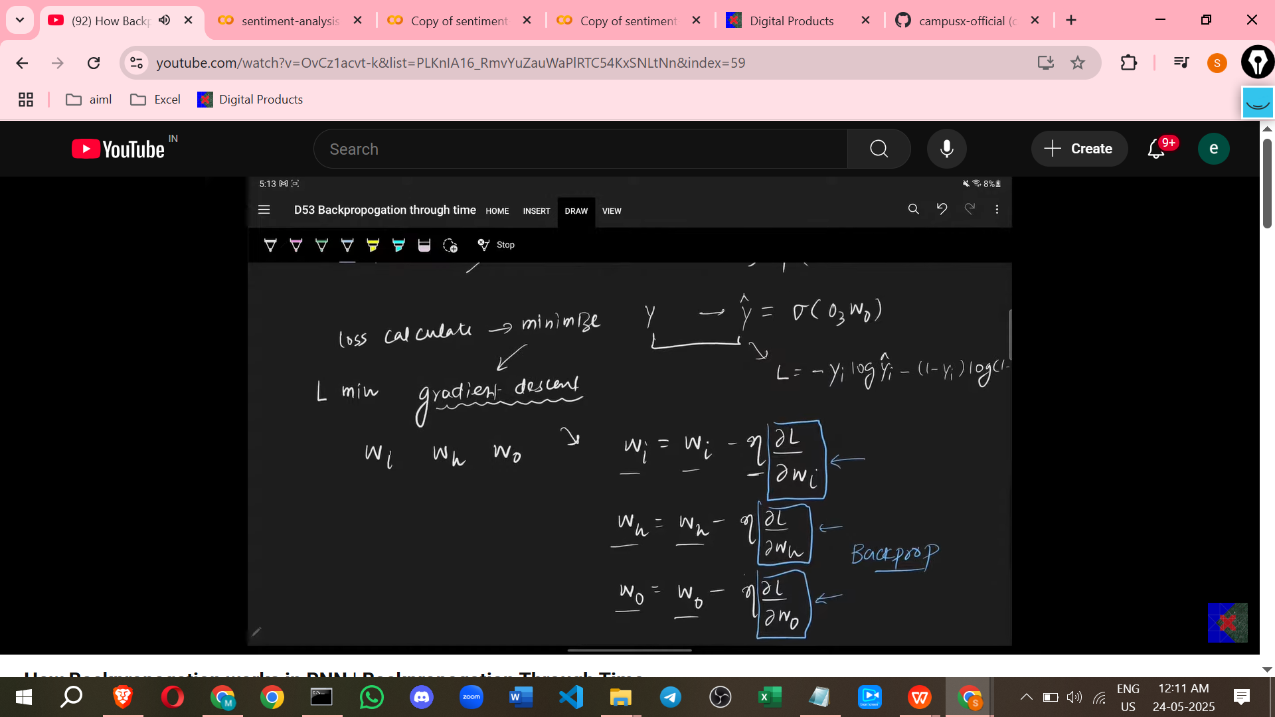

**Goal of Backpropagation**

* The goal is to **minimise the calculated loss**.
* This is achieved by **adjusting the network's weights** (W_I, W_H, W_O) using an optimisation algorithm like Gradient Descent.
* Gradient Descent requires calculating the **gradient of the loss with respect to each weight matrix** (∂L/∂W_O, ∂L/∂W_I, ∂L/∂W_H).
* The weight updates follow the formula: W_new = W_old - learning_rate * ∂L/∂W.

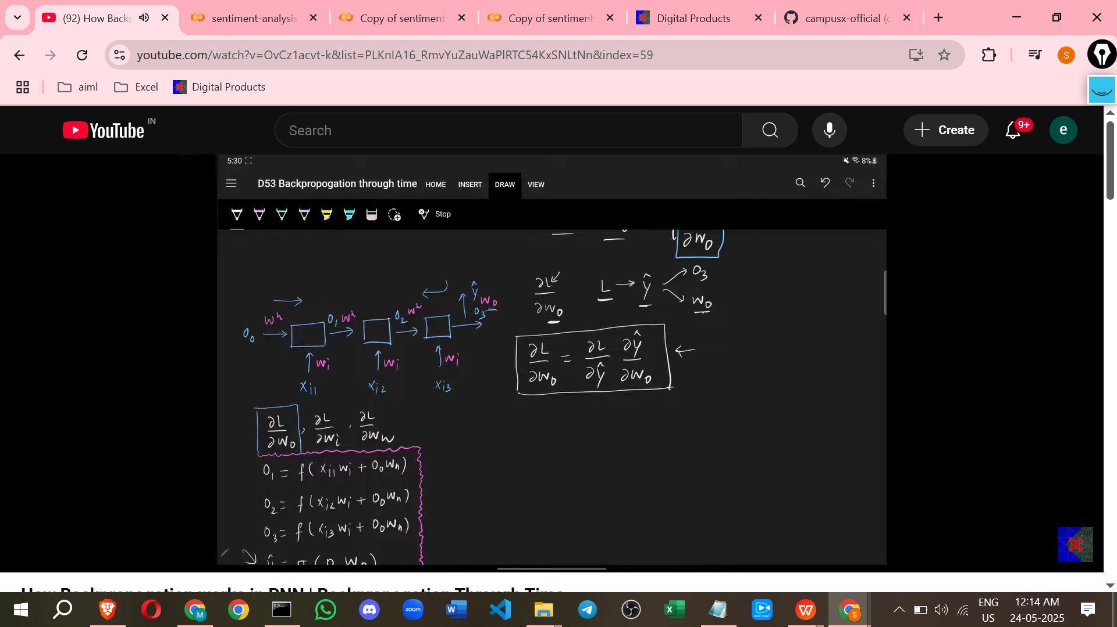

**Calculating Gradients (Derivatives)**

* Backpropagation proceeds **backwards from the output layer** towards the input layers.

1. **Derivative with respect to W_Output (∂L/∂W_O)**
   * This is the **easiest derivative to calculate** because W_O is directly connected to the final output layer where the loss is computed.
   * The loss (L) depends on y_hat, and y_hat depends on O3 (the final hidden state) and W_O.
   * The derivative ∂L/∂W_O can be calculated using the chain rule: ∂L/∂W_O = (∂L/∂y_hat) * (∂y_hat/∂W_O). This involves differentiating the loss function with respect to y_hat and the output activation function output (y_hat) with respect to W_O.
2. **Derivative with respect to W_Input (∂L/∂W_I)**
   * Calculating this derivative is **more complex**.
   * The input weight W_I is used at **every time step** (to process the input word at that step).
   * The loss L depends on y_hat, which depends on O3, which depends on O2, which depends on O1, and each O_t (O1, O2, O3) depends on W_I (via processing X_t).
   * There are **multiple paths** through the unfolded network connecting the loss L to the input weight W_I across different time steps.
   * To find ∂L/∂W_I, you need to sum the contributions of W_I at each time step to the total loss. This is done by applying the **chain rule through each path** from L back to W_I at time step 1, W_I at time step 2, etc., and summing these contributions.
   * For the 3-word example, the derivative is a sum of three terms, representing the influence of W_I at time step 1, time step 2, and time step 3 on the final loss.
   * This summation can be represented compactly: ∂L/∂W_I = Σ (from j=1 to N) ∂L/∂O_j * ∂O_j/∂W_I, where N is the number of time steps (words). The term ∂L/∂O_j represents propagating the gradient back from the final loss to the hidden state at time step j.
3. **Derivative with respect to W_Hidden (∂L/∂W_H)**
   * This is also **complex** because the hidden weight W_H is used in the recurrent connection at **every single time step**.
   * The loss L depends on y_hat, which depends on O3. O3 depends on O2 and W_H. O2 depends on O1 and W_H. O1 depends on O0 (initial) and W_H (processing X1).
   * Similar to W_I, there are **multiple paths** through the unfolded network connecting the loss L to the hidden weight W_H across different time steps.
   * To find ∂L/∂W_H, you sum the contributions of W_H at each time step to the total loss.
   * The derivative is a sum of terms, where each term represents the path from the loss back through the network to the hidden weight connection at a specific time step.
   * Equation structure involves summing gradients propagated back through time. The source illustrates paths like L -> y_hat -> O3 -> W_H (for the connection contributing to O3), L -> y_hat -> O3 -> O2 -> W_H (for the connection contributing to O2), and L -> y_hat -> O3 -> O2 -> O1 -> W_H (for the connection contributing to O1).

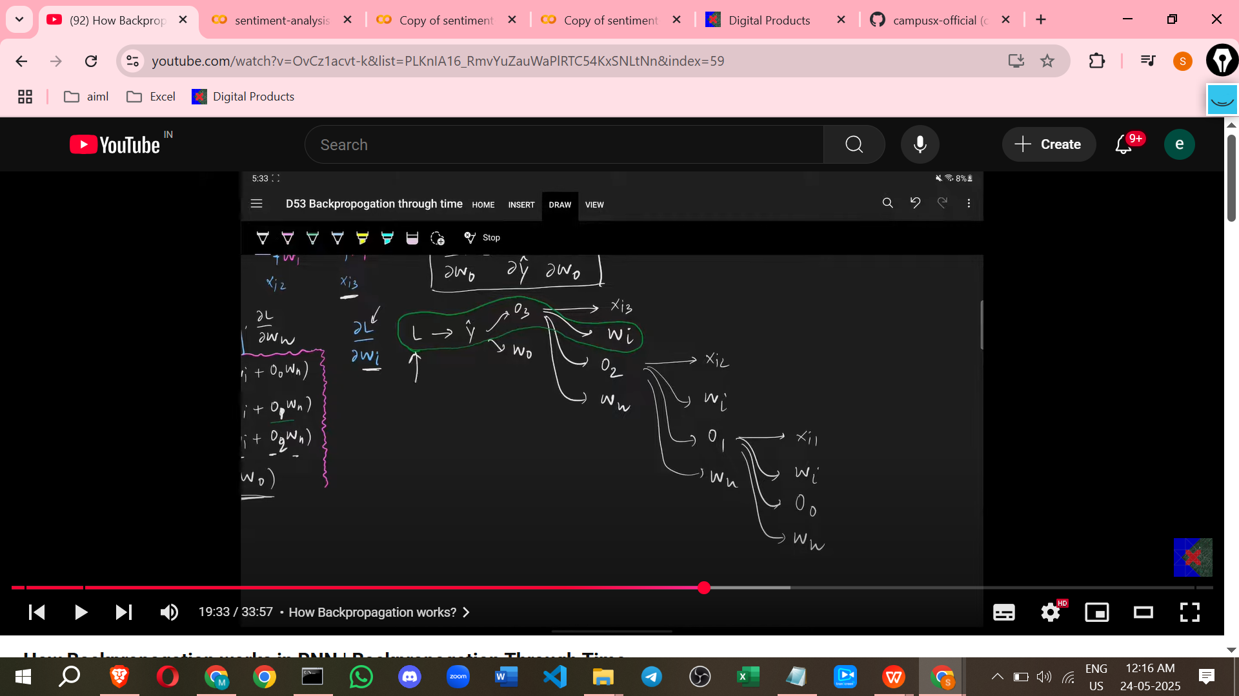

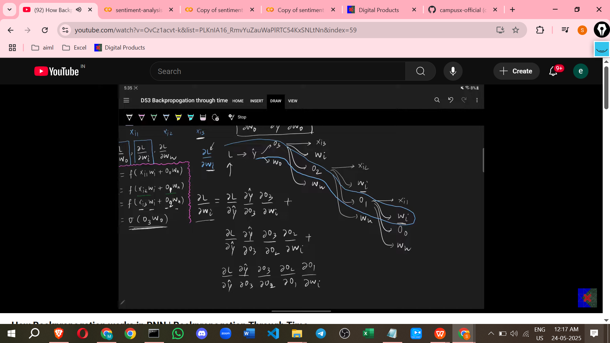

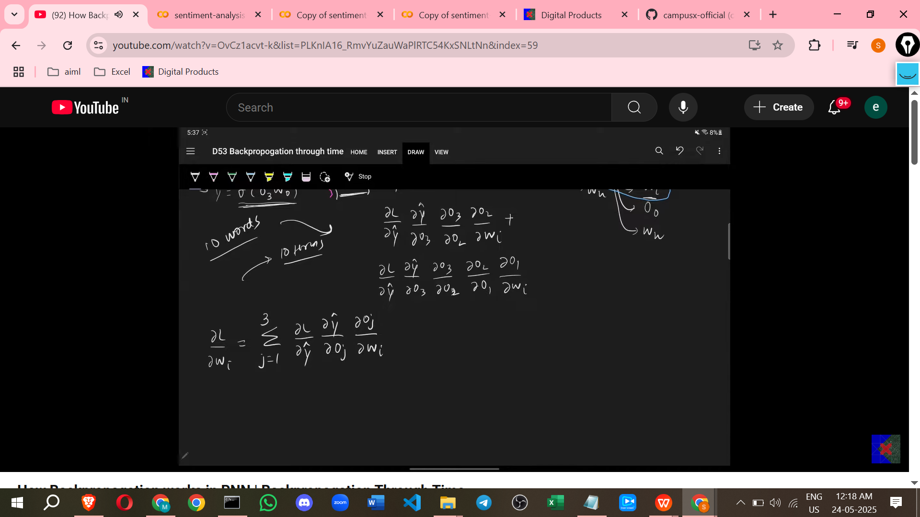

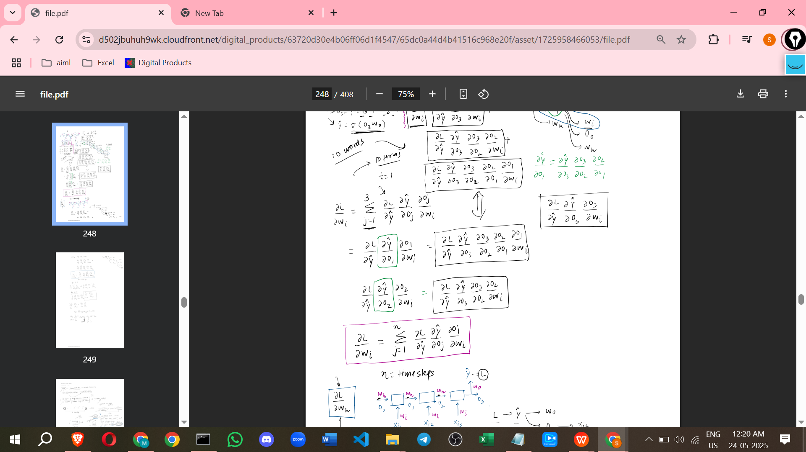

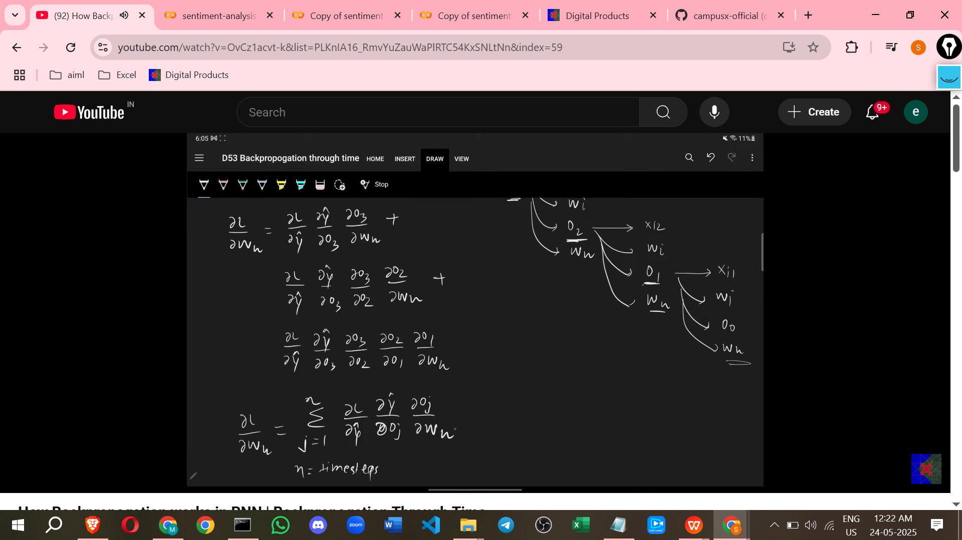

**Training Process**

* The training process involves iterating through the data (reviews).
* For each review:
  + Perform **forward propagation** word by word through the unfolded network to get the final output (y_hat).
  + Calculate the **loss** based on y_hat and the true label (y).
  + Perform **backpropagation through time** to calculate the derivatives ∂L/∂W_O, ∂L/∂W_I, and ∂L/∂W_H.
  + Update the weights (W_O, W_I, W_H) using the calculated derivatives and the learning rate.
* Repeat this process for many iterations (epochs) until the loss is minimised and the model's predictions are accurate.

**Points Good to Understand the Concept**

* **Unfolding in Time:** The core idea of BPTT is mentally or computationally unfolding the recurrent network for each input sequence length. This transforms the recurrent structure into a standard feedforward-like structure across the time dimension.
* **Shared Weights:** Crucially, the **same weight matrices (W_I, W_H, W_O) are used at every time step** of the unfolded network. This is what makes the weights "shared" across time. This sharing is why calculating the total derivative with respect to W_I and W_H requires summing up the gradients calculated at each time step where that weight matrix was used.
* **Chain Rule:** BPTT is fundamentally an application of the **chain rule of calculus**. To find how much the loss changes with respect to a weight, you multiply the rates of change along the path(s) from the loss back to that weight. For weights W_I and W_H, because they are used multiple times, you must sum the contributions from all the paths.
* **Comparison to Standard Backpropagation:** The source notes that they have discussed backpropagation before in the context of simpler neural networks (MLPs). The core mechanics (calculating derivatives, gradient descent) are similar, but the "Through Time" aspect of RNNs adds the complexity of **propagating gradients across time steps** and summing contributions from shared weights.
* **Dependency Across Time:** The hidden state at time step t depends on the hidden state at time step t-1. This sequential dependency means that changes in weights (especially W_H) and inputs at earlier time steps can propagate and influence the final output. BPTT accounts for this influence.

===========================================================

# **Class 6. Problems with RNN**

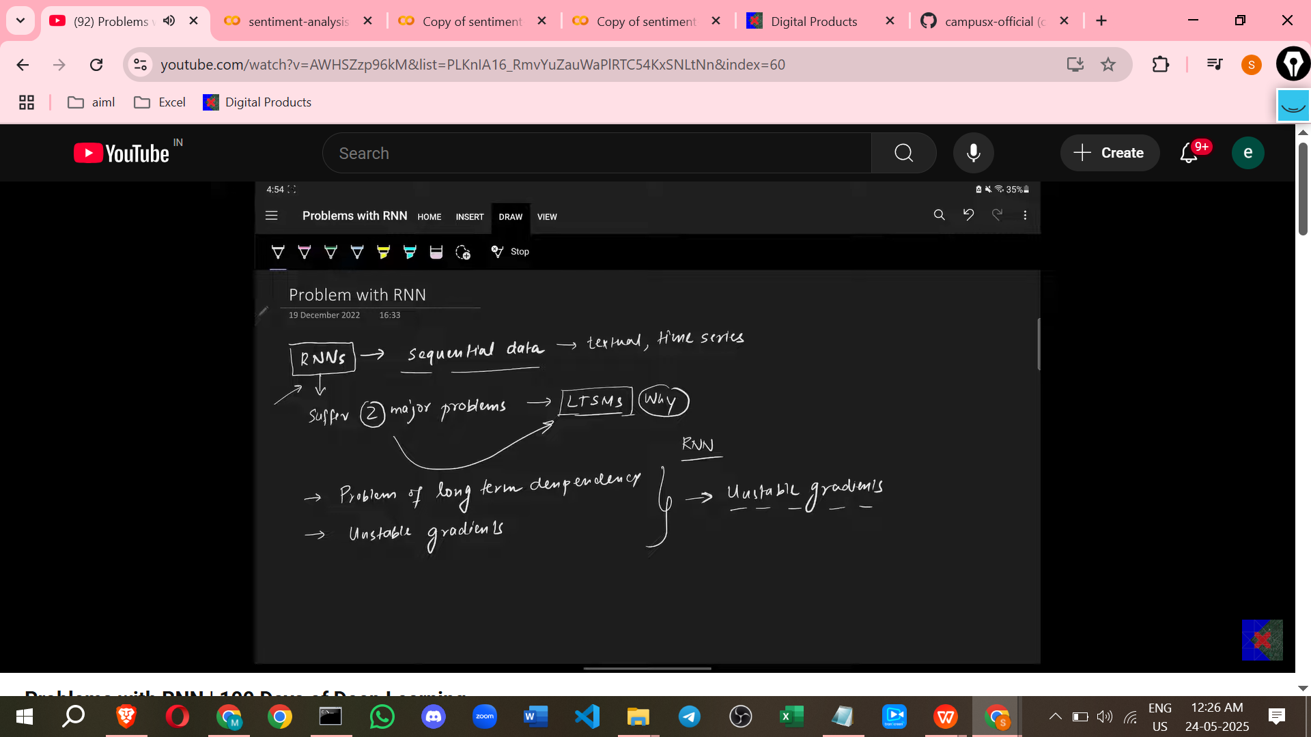

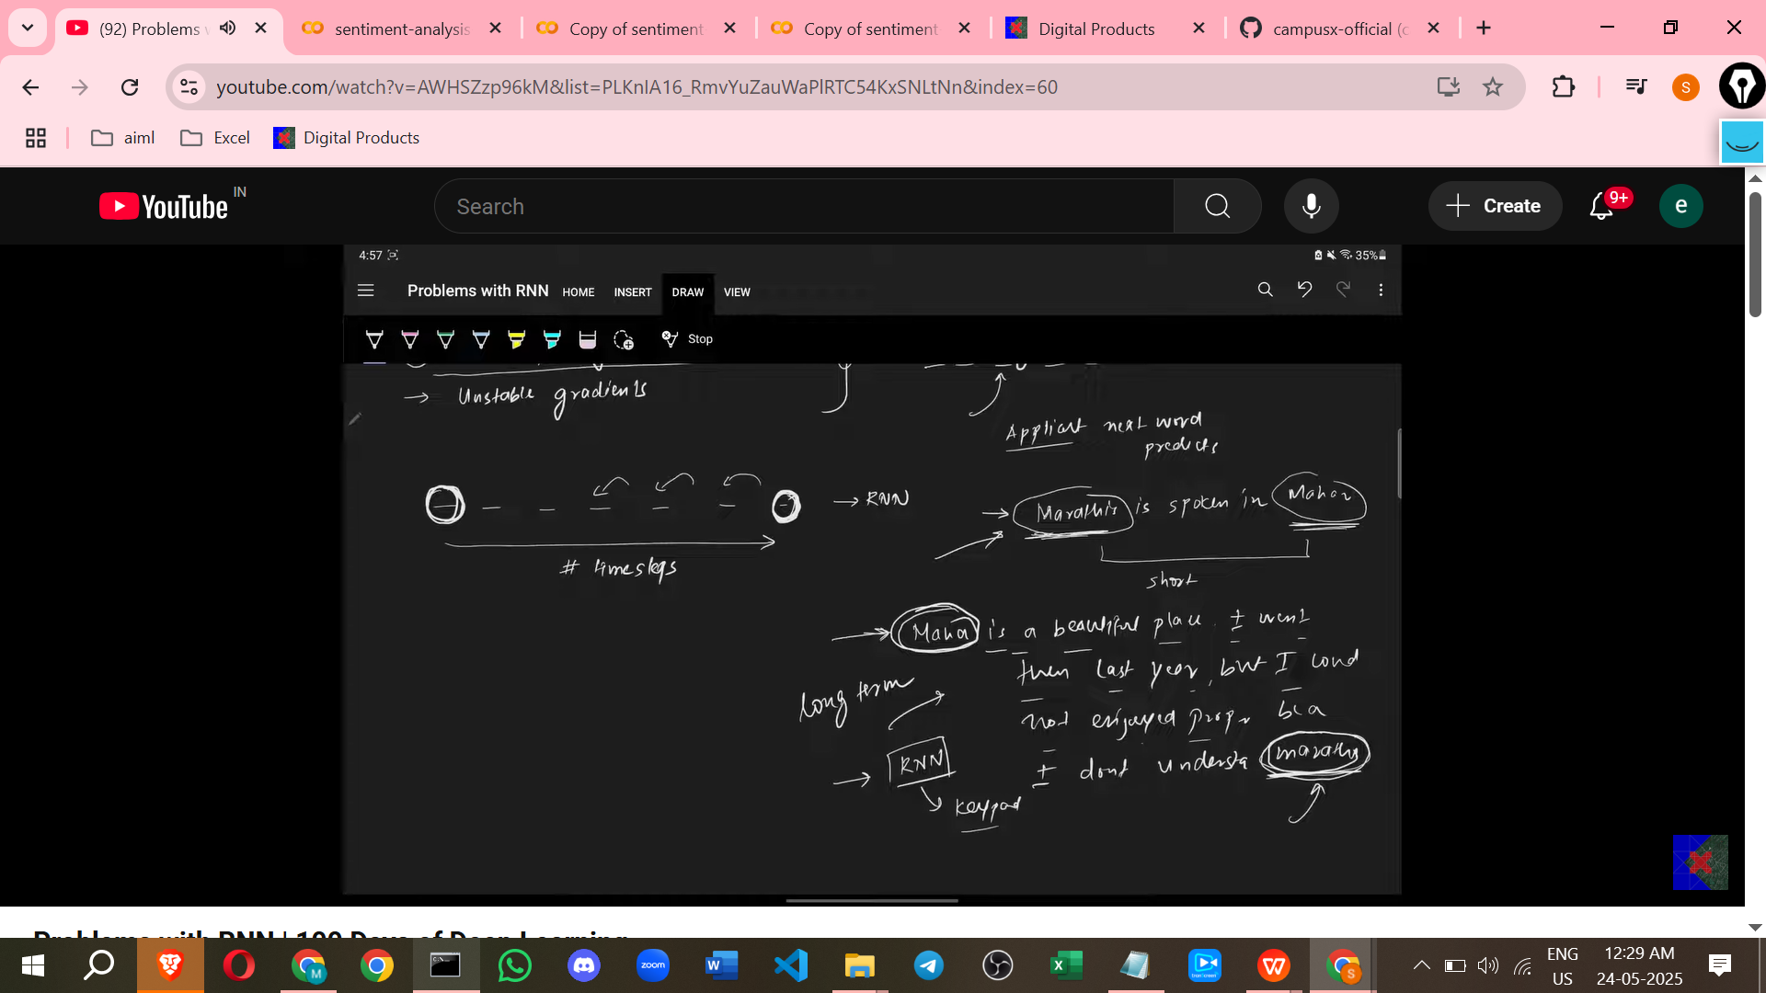

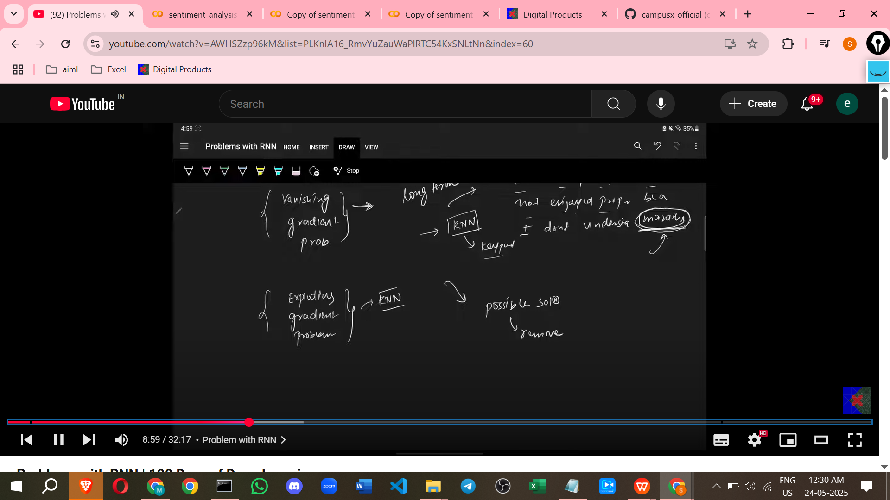

**Problems with Standard RNNs**

1. **Problem of Long Term Dependency**

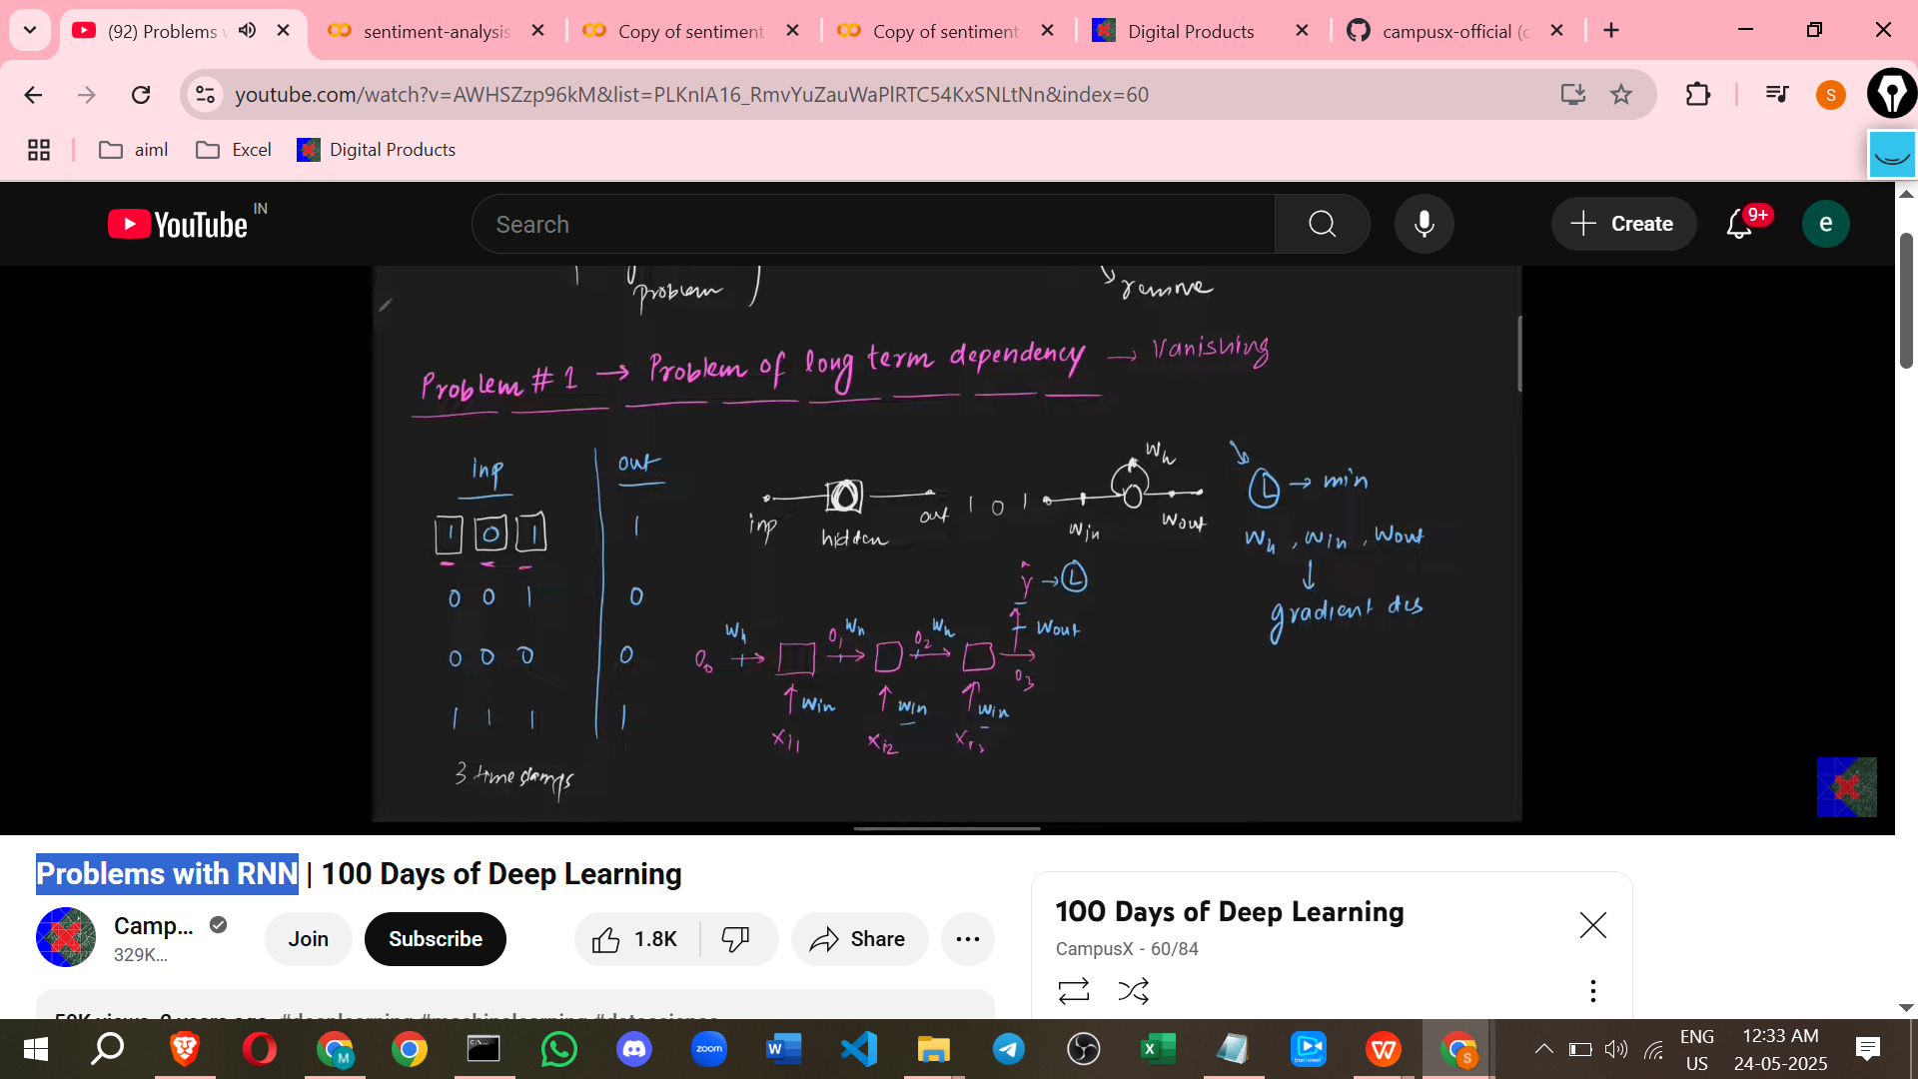

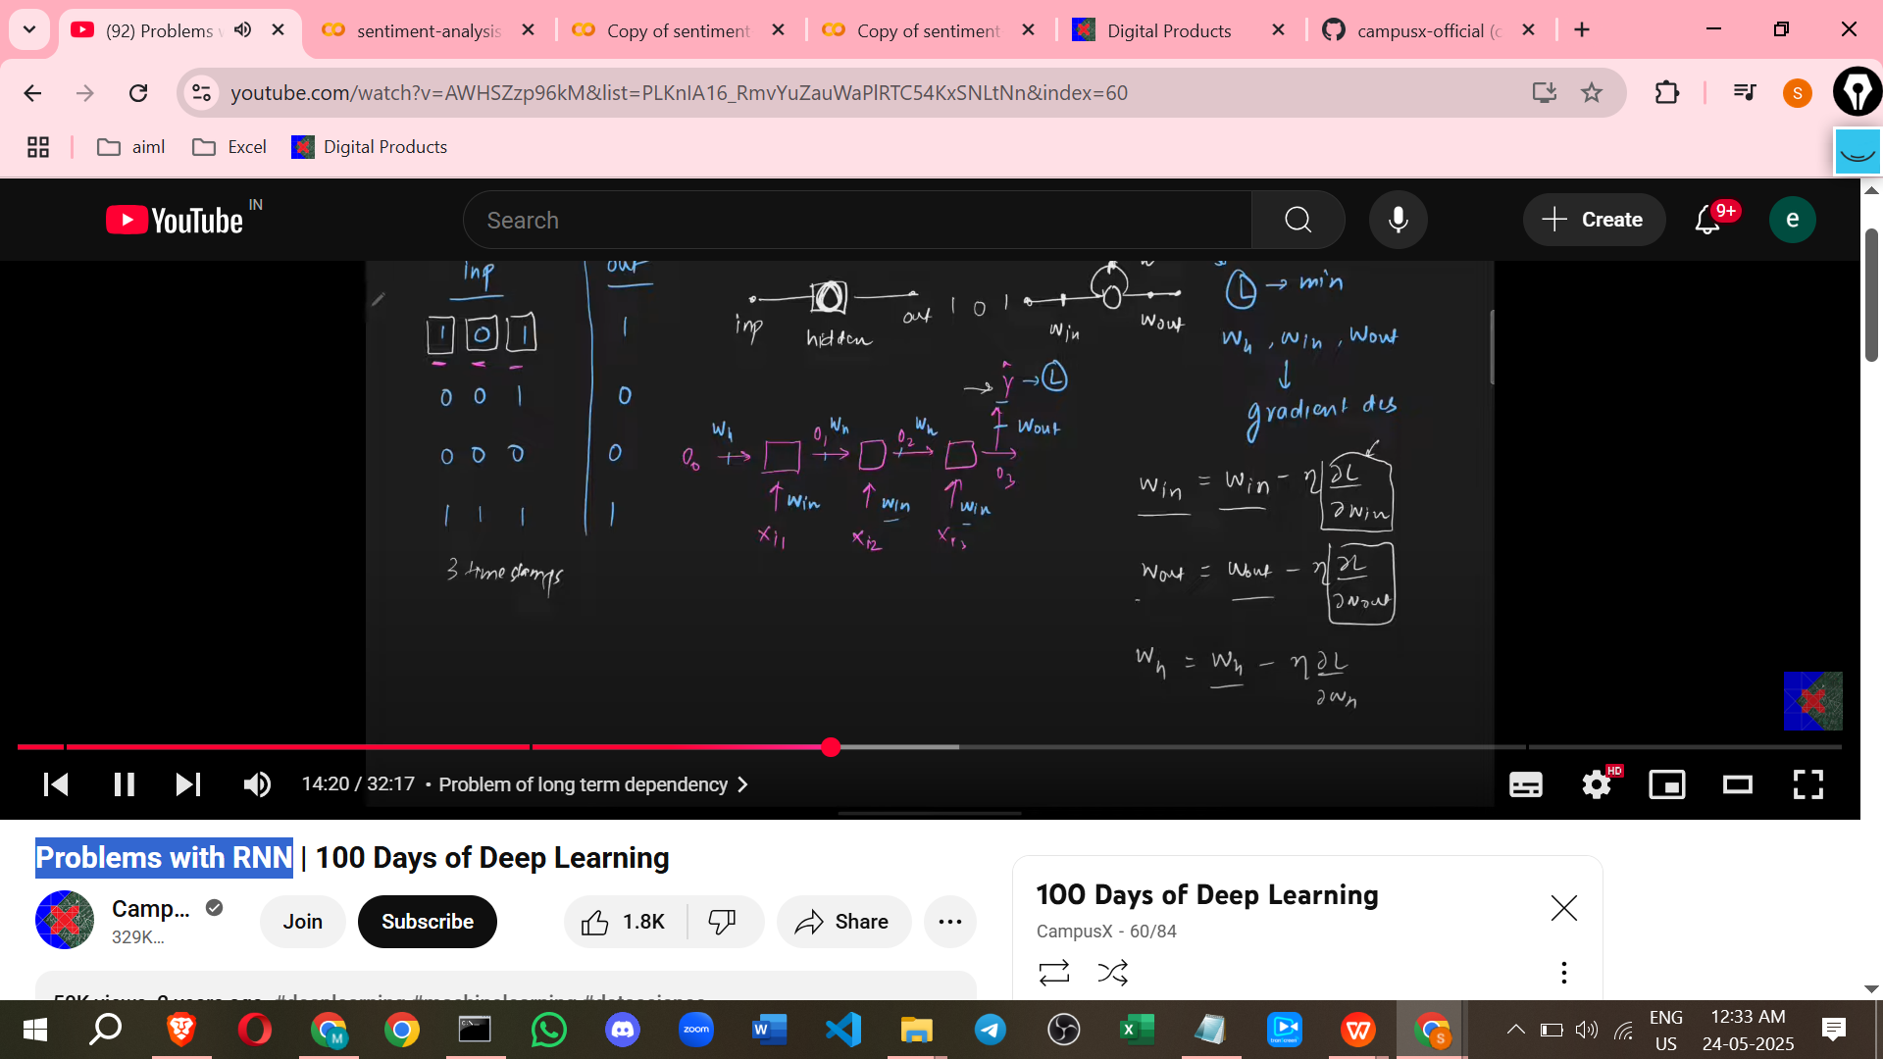

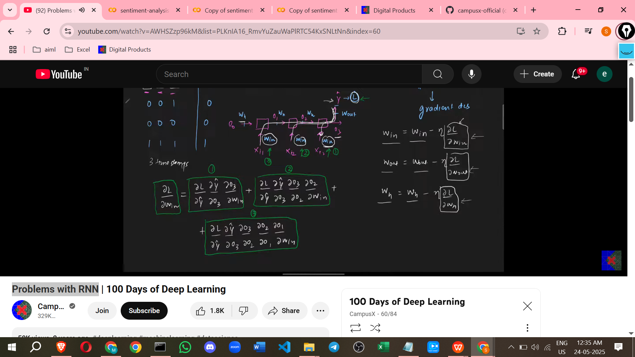

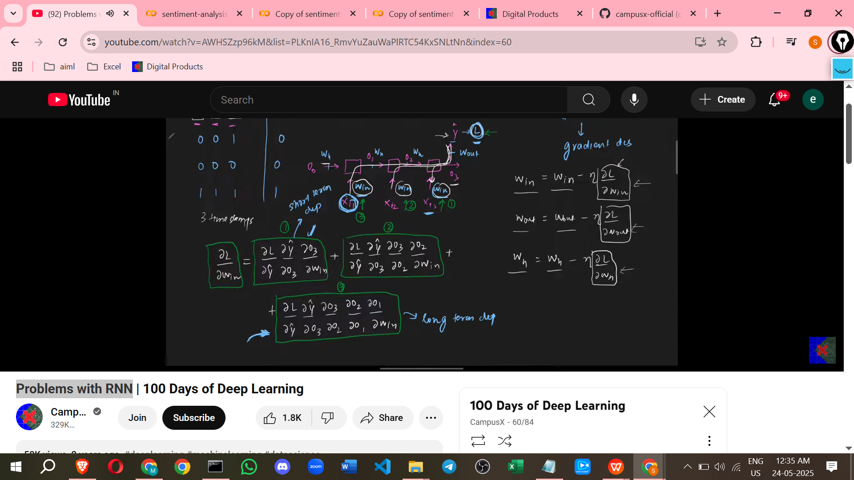

**For long term like 100 time stamps**

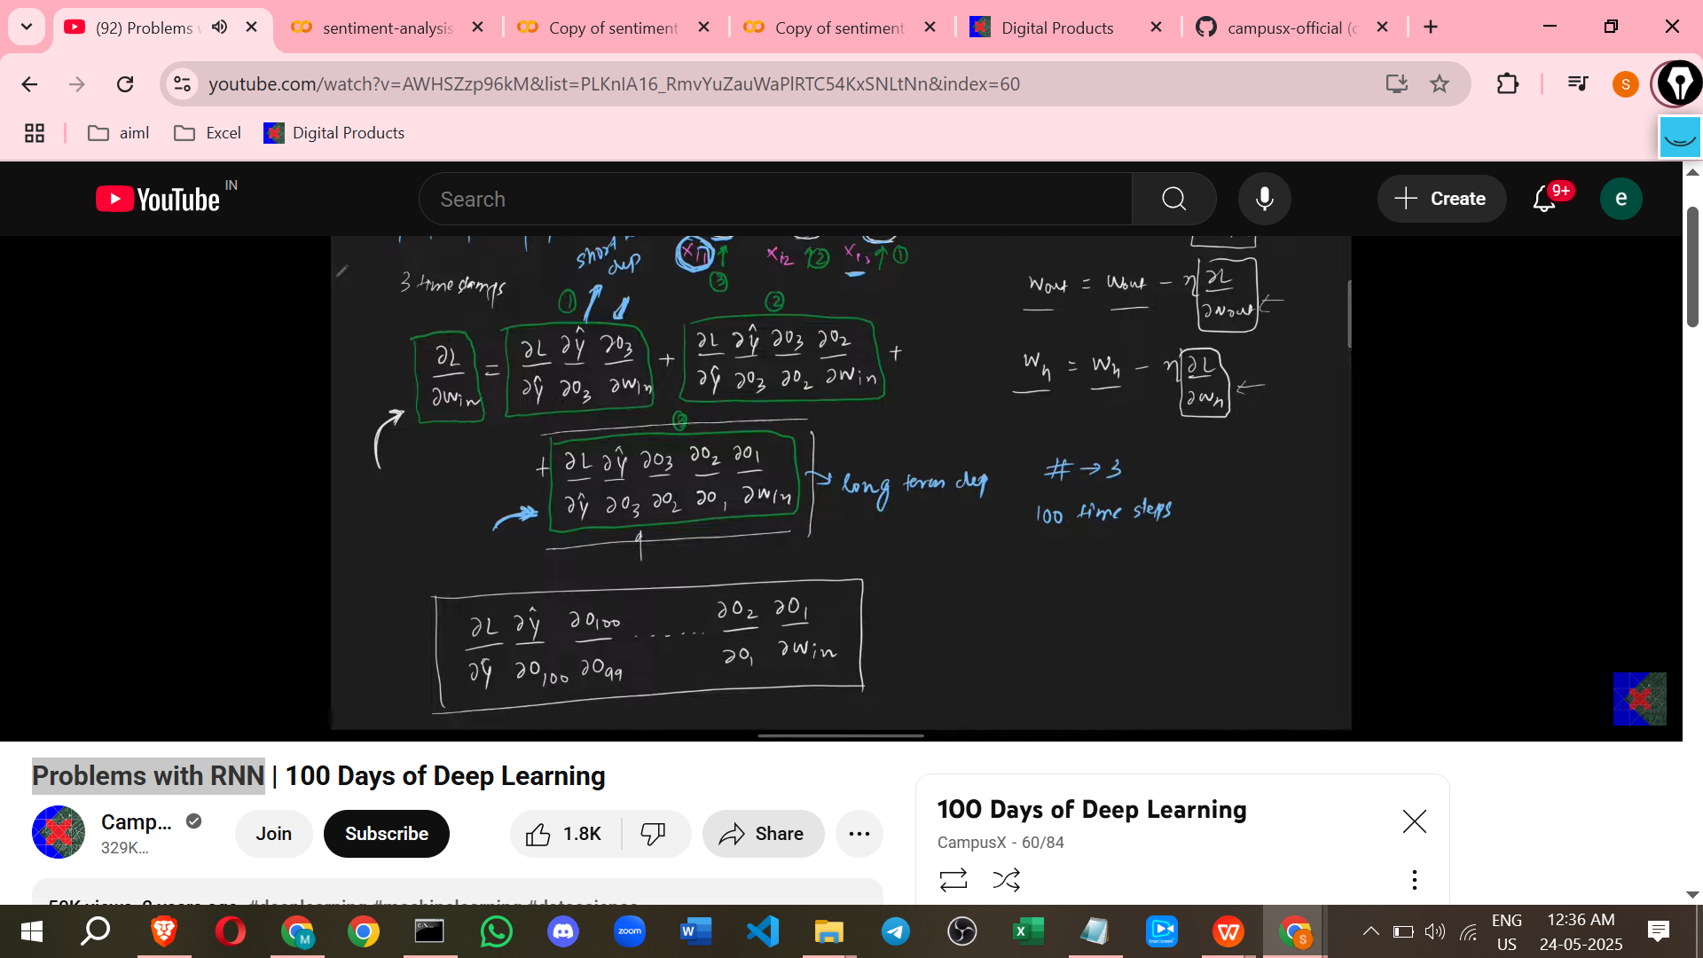

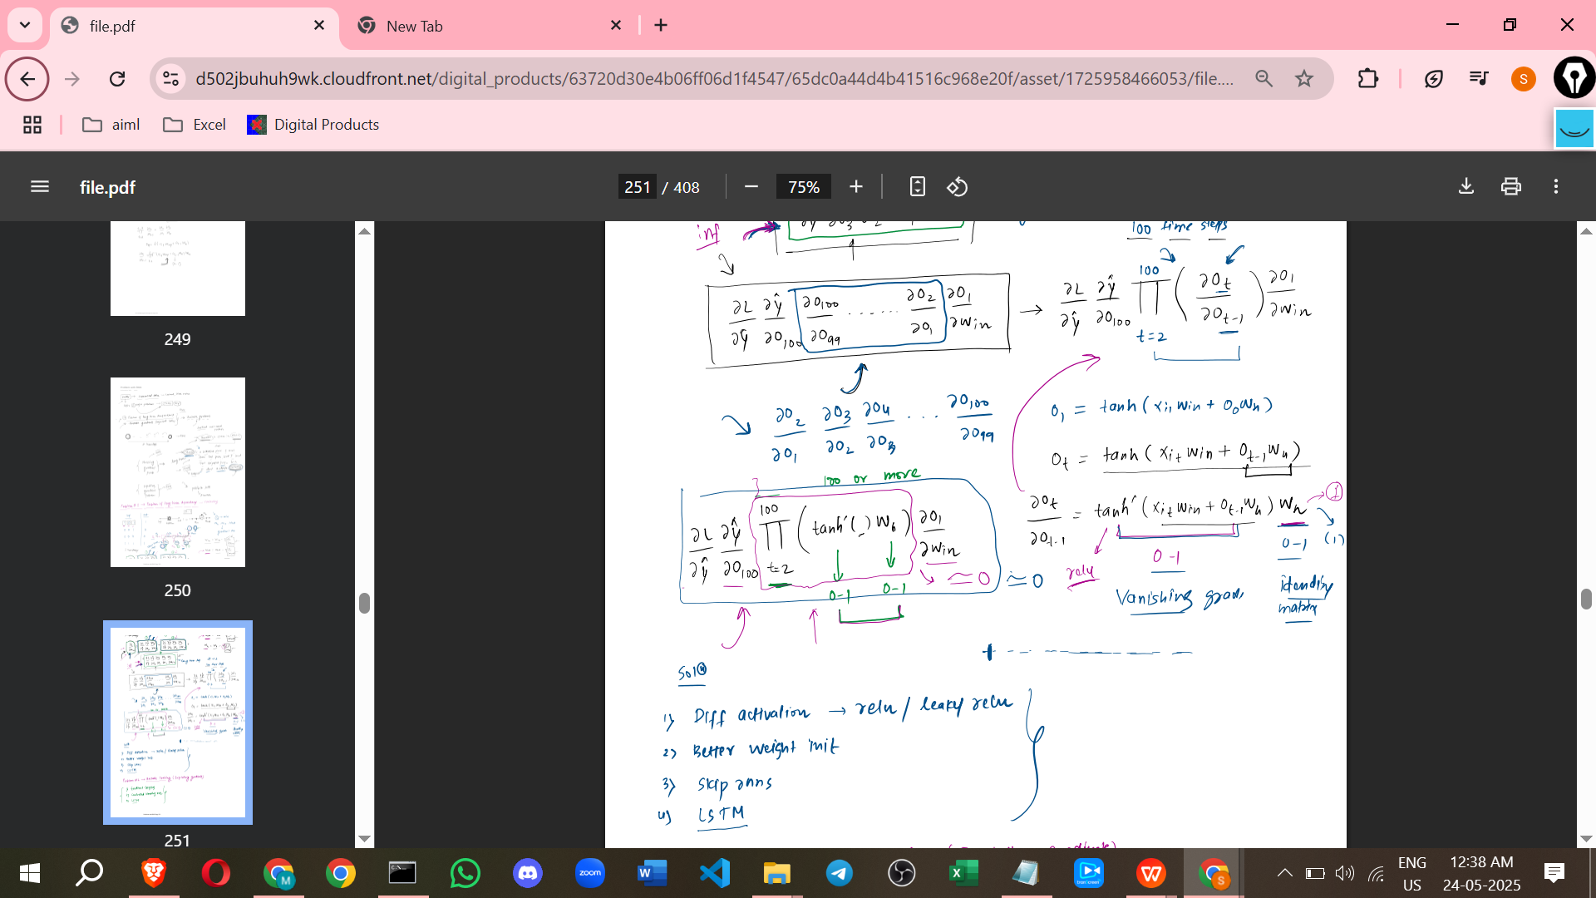

* + **Description:** This problem arises when information from a distant past time step is crucial for predicting the output at the current time step. Standard RNNs struggle to retain and use this information over long sequences. It's likened to a short-term memory loss, where the network forgets information from earlier time steps as it processes later ones.
  + **Example:** Predicting the last word in a sentence like "I was born in France, I speak fluent [French]" requires remembering the word "France" which appeared early in the sentence. RNNs might fail in such situations, especially with longer sentences, performing better on shorter sentences.
  + **Cause: Vanishing Gradient Problem**
    - During training (specifically, backpropagation through time), gradients (which indicate how much weights should change to reduce error) are calculated by chaining derivatives across multiple time steps.
    - When calculating the gradient of the loss with respect to weights (like W_h or W_in) that influence early time steps, the calculation involves multiplying many derivatives of the activation function and the recurrent weight W_h.
    - If the activation function's derivative (e.g., the derivative of tanh) and the value of the recurrent weight W_h are typically between 0 and 1, multiplying many such values together results in a very small number, approaching zero.
    - *Additional Note:* The derivative of the tanh function ranges between 0 and 1. Specifically, it's 1 at input 0 and approaches 0 as the input moves away from 0. When multiplied repeatedly across many layers or time steps, this can cause the gradient to shrink exponentially.
    - This causes the gradient contribution from earlier time steps (long-term dependencies) to become negligible compared to contributions from recent time steps (short-term dependencies).
    - Consequently, the weights are primarily updated based on short-term dependencies, and the network fails to learn long-term relationships in the data.

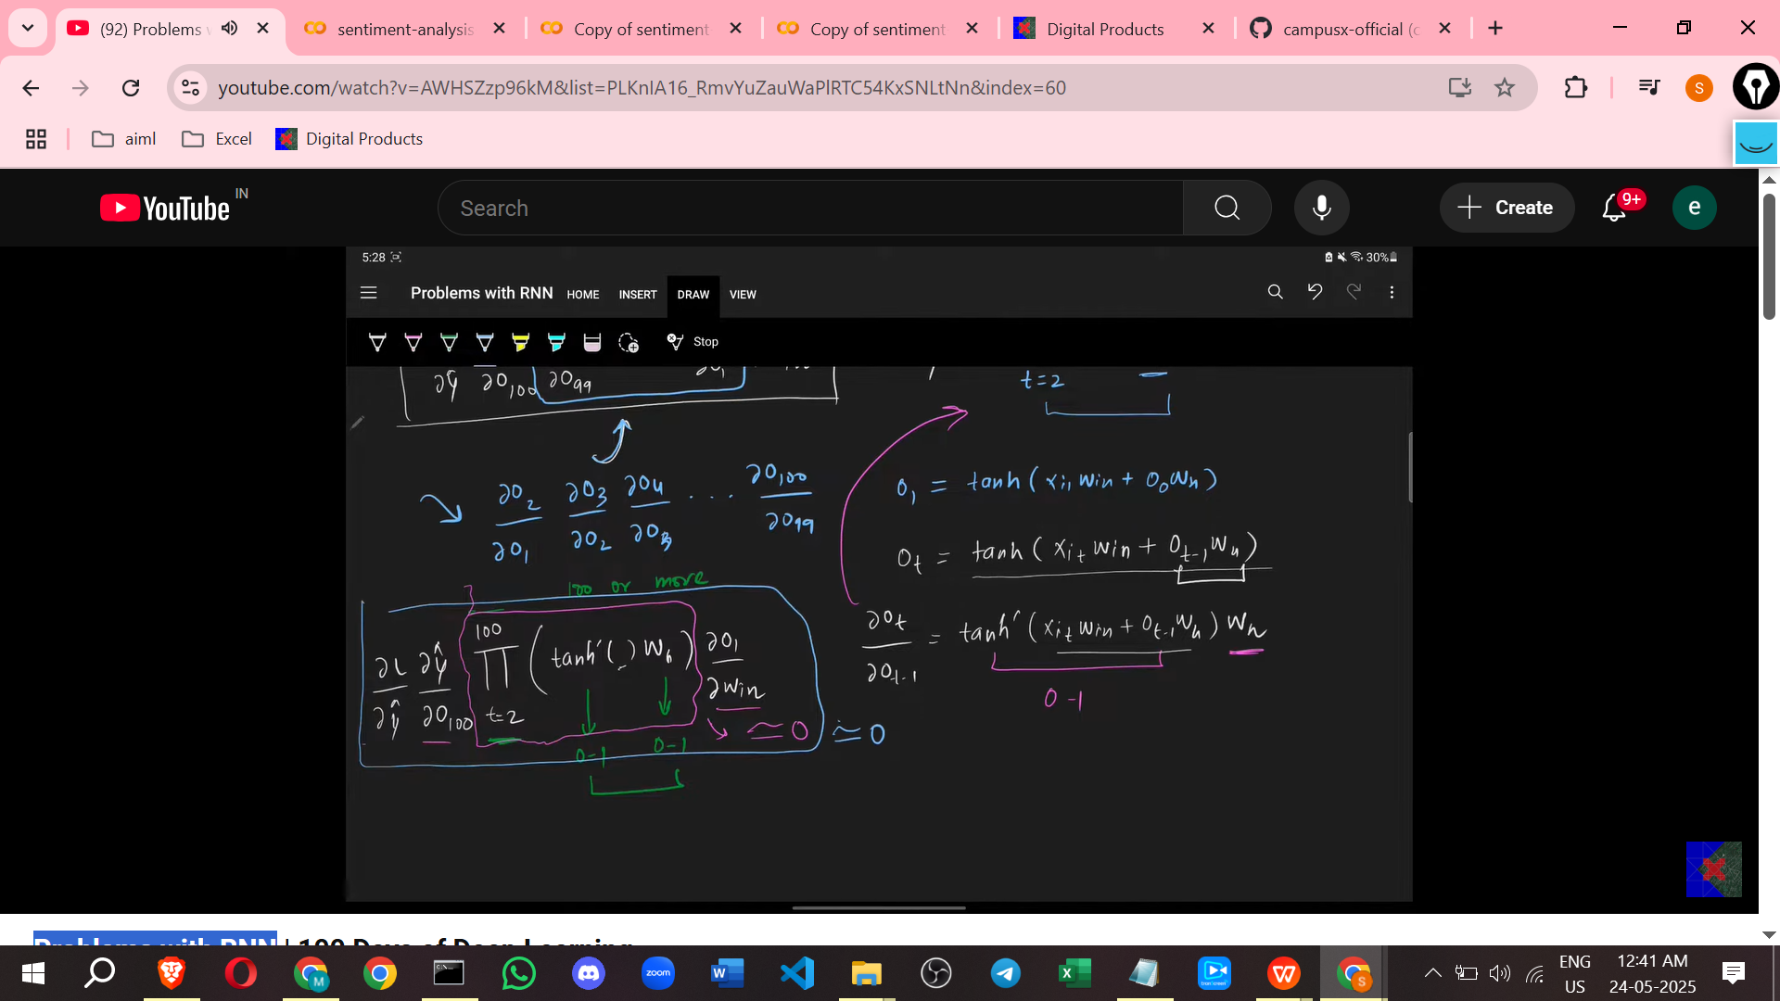

* + **Consequence:** The network's output is dominated by recent inputs, making it unable to leverage information from far back in the sequence. This limits the effectiveness of RNNs on tasks requiring long-term memory.
  + **Possible Solutions Mentioned:**
    - Using different activation functions, such as ReLU, whose derivative is not always in the range for positive inputs.
    - Using better weight initialization techniques, like initializing W_h close to an identity matrix, which can help prevent the gradients from shrinking excessively during multiplication.
    - Using slightly different architectures, like skip connections (not explained in detail in the video).
    - *Additional Note:* Skip connections, often used in other network architectures like ResNets, allow gradients to flow more directly through the network by creating shortcut paths.

1. **Problem of Unstable Training**

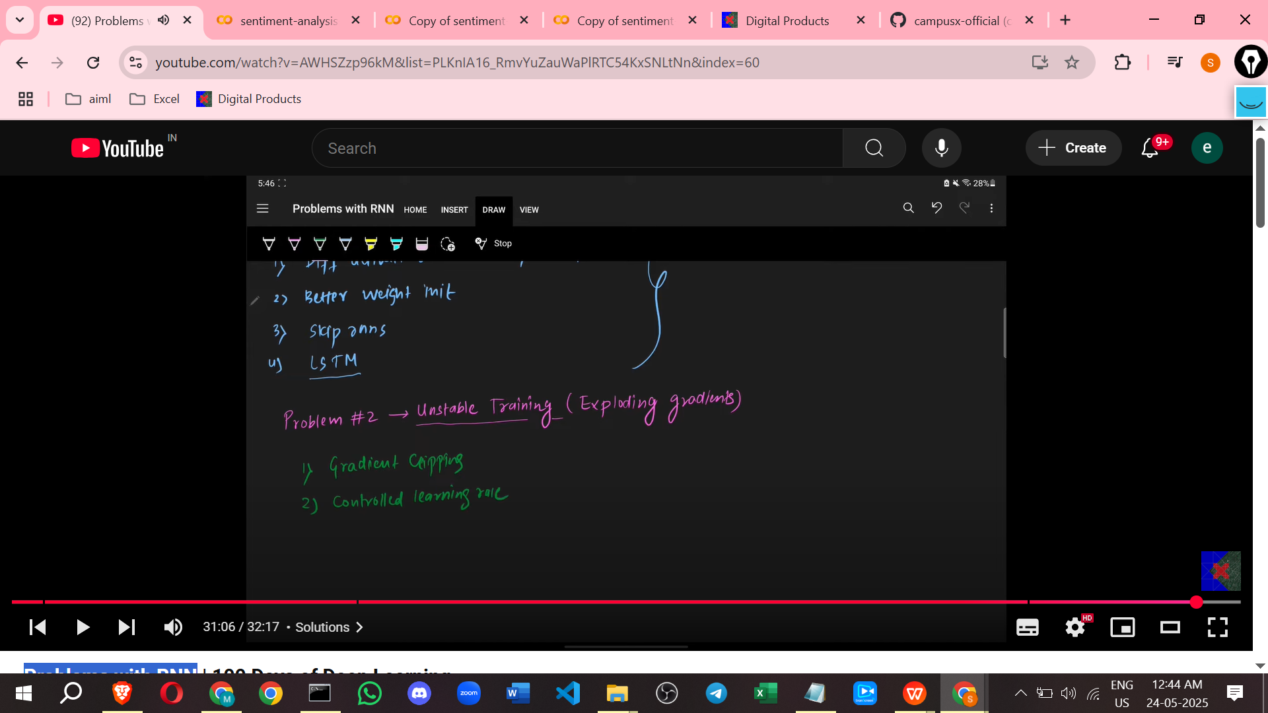

* + **Description:** Sometimes, standard RNNs can be difficult or impossible to train properly. The loss function might not improve effectively. This is referred to as unstable training.
  + **Cause: Exploding Gradient Problem**
    - This is the opposite scenario to the vanishing gradient problem. It also arises from the repeated multiplication of derivatives during backpropagation through time.
    - If the activation function's derivative or the recurrent weight W_h values are large (greater than 1), multiplying them repeatedly can result in an extremely large number, approaching infinity.
    - *Additional Note:* This can happen if activation functions like ReLU are used (derivative is 1 for positive input) in combination with large weights W_h.
    - The large gradients cause very large updates to the network's weights.
  + **Consequence:** Weights can become excessively large or even infinite, leading to numerical instability and preventing the model from training effectively or at all. The gradient calculation can be dominated by a few very large values.
  + **Possible Solutions Mentioned:**
    - **Gradient Clipping:** This technique involves setting a maximum threshold for the magnitude of the gradients. If a gradient exceeds this threshold, it is scaled down proportionally. This prevents the gradients and consequently the weight updates from becoming excessively large.
    - Using a smaller learning rate can also help prevent exploding gradients, although it's not explicitly mentioned as a primary solution in the source.

These problems highlight the limitations of simple RNN architectures, making more sophisticated designs like LSTMs necessary because they are built to address these gradient issues. LSTMs are widely used in real-world applications because they can handle long-term dependencies better.

=====================================